|  |  |
| --- | --- |
| Project Title | Writing Wireshark Filter Expressions for Packet Capture |
| Project Domain | Network Analysis |
| Name of the Institute | Bennett University |
| Browser | Google Chrome |
| Local IP Address | 192.168.56.1 |

|  |  |  |  |  |
| --- | --- | --- | --- | --- |
| Start Date | End Date | Total Effort (hrs.) | Project Environment | Tools used |
| 28/11/2021 | 30/11/2021 | 12 | Online | Wireshark |

**Writing Wireshark Filter Expressions for Packet Capture**

**Introduction**

Wireshark is an open-source packet analyzer, which is used for education, analysis, software development, communication protocol development, and network troubleshooting.

It is used to track the packets so that each one is filtered to meet our specific needs. It is commonly called as a sniffer, network protocol analyzer, and network analyzer. It is also used by network security engineers to examine security problems.

Wireshark is a free to use application which is used to apprehend the data back and forth. It is often called as a free packet sniffer computer application. It puts the network card into an unselective mode, i.e., to accept all the packets which it receives.

Like any other packet sniffer, Wireshark does three things:

* **Packet Capture**: Wireshark listens to a network connection in real time and then grabs entire streams of traffic – quite possibly tens of thousands of packets at a time.
* **Filtering**: Wireshark is capable of slicing and dicing all of this random live data using filters. By applying a filter, you can obtain just the information you need to see.
* **Visualization**: Wireshark, like any good packet sniffer, allows you to dive right into the very middle of a network packet. It also allows you to visualize entire conversations and network streams.

**Applications of Wireshark:**

* It is used by network security engineers to examine security problems.
* It allows the users to watch all the traffic being passed over the network.
* It is used by network engineers to troubleshoot network issues.
* It also helps to troubleshoot latency issues and malicious activities on your network.
* It can also analyze dropped packets.
* It helps us to know how all the devices like laptop, mobile phones, desktop, switch, routers, etc., communicate in a local network or the rest of the world.

**Important Keywords**

* **Packet:** A packet is a unit of data which is transmitted over a network between the origin and the destination. Network packets are small, i.e., maximum 1.5 Kilobytes for Ethernet packets and 64 Kilobytes for IP packets. The data packets in the Wireshark can be viewed online and can be analyzed offline.
* **HTTP:** Hypertext Transfer Protocol (HTTP) is an application-layer protocol for transmitting hypermedia documents, such as HTML. It was designed for communication between web browsers and web servers, but it can also be used for other purposes. HTTP follows a classical client-server model, with a client opening a connection to make a request, then waiting until it receives a response. HTTP is a stateless protocol, meaning that the server does not keep any data (state) between two requests.
* **IP Address:** An IP address is a unique address that identifies a device on the internet or a local network. IP stands for "Internet Protocol," which is the set of rules governing the format of data sent via the internet or local network.

IP addresses are the identifier that allows information to be sent between devices on a network: they contain location information and make devices accessible for communication. The internet needs a way to differentiate between different computers, routers, and websites. IP addresses provide a way of doing so and form an essential part of how the internet works.

* **TCP:** The transmission control protocol (TCP) is the internet standard ensuring the successful exchange of data packets between devices over a network. TCP is the underlying communication protocol for a wide variety of applications, including web servers and websites, email applications, FTP, and peer-to-peer apps.

TCP operates with the internet protocol (IP) to specify how data is exchanged online. IP is responsible for sending each packet to its destination, while TCP guarantees that bytes are transmitted in the order in which they were sent with no errors or omissions. Together, the two protocols are referred to as TCP/IP.

* **SYN Packets**: Short for synchronize, SYN is a TCP packet sent to another computer requesting that a connection be established between them. SYN packets are normally generated when a client attempts to start a TCP connection to a server, and the client and server exchange a series of messages, which normally runs like this:
* The client requests a connection by sending a SYN (synchronize) message to the server.
* The server acknowledges this request by sending SYN-ACK back to the client.
* The client responds with an ACK, and the connection is established.

This is called the TCP three-way handshake, and it’s the foundation for every connection established using the TCP protocol. In the past, attackers could bring down a firewall by sending lots of SYN packets, this is also known as a SYN flood attack. Each SYN packet would use up firewall resources and eventually, it would stop accepting new connections. This can result in a massive business problem now that so many applications are cloud-based and need fast and reliable internet access.

* **Capture Filter:** Capture filters only keep copies of packets that match the filter. Capture filters use a syntax of byte offsets, hex values, and masks coupled with Booleans to filter. Capture filters are less intuitive, as they are cryptic when compared to display filters.
* **Display Filters:** Display filters are used when you’ve captured everything but need to cut through the noise to analyze specific packets or flows. Display filters use a syntax of Boolean operators and fields that intuitively describe what you’re filtering on. Display filters aren’t that hard to write once you’ve created a few.
* **Control Flags**: TCP uses nine control flags to manage data flow in specific situations. Following are the most used TCP flags:
* **Synchronization Flag (SYN)** – It is used in first step of connection establishment phase or 3-way handshake process between the two hosts. Only the first packet from sender as well as receiver should have this flag set. This is used for synchronizing sequence number that is to tell the other end which sequence number they should accept.
* **Acknowledgement Flag (ACK)** – It is used to acknowledge packets which are successful received by the host. The flag is set if the acknowledgement number field contains a valid acknowledgement number.

For instance, when the receiver sends an ACK = 1 as well as SYN = 1 in the second step of connection establishment, it is to tell sender that it has received its initial packet.

* **Finish Flag (FIN)** – It is used to request for connection termination that is when there is no more data from the sender, it requests for connection termination. This is the last packet sent by sender. It frees the reserved resources and gracefully terminate the connection.
* **Reset Flag (RST)** – It is used to terminate the connection if the RST sender feels something is wrong with the TCP connection or that the conversation should not exist. It can get send from receiver side when packet is sent to particular host that was not expecting it.
* **Push Flag (PSH)** – Transport layer by default waits for some time for application layer to send enough data equal to maximum segment size so that the number of packets transmitted on network minimizes which is not desirable by some application like interactive applications(chatting). Similarly transport layer at receiver end buffers packets and transmit to application layer if it meets certain criteria.

This problem is solved by using PSH. Transport layer sets PSH = 1 and immediately sends the segment to network layer as soon as it receives signal from application layer. Receiver transport layer, on seeing PSH = 1 immediately forwards the data to application layer.

In general, it tells the receiver to process these packets as they are received instead of buffering them.

* **Urgent (URG)** –Data inside a segment with URG = 1 flag is forwarded to application layer immediately even if there are more data to be given to application layer. It is used to notify the receiver to process the urgent packets before processing all other packets. The receiver will be notified when all known urgent data has been received.
* **Congestion Window Reduced Flag (CWR):** The congestion window reduced flag is used by the sending host to indicate it received a packet with the ECE flag set.

|  |  |  |
| --- | --- | --- |
| **S.No.** | **Finish Flag (FIN)** | **Reset Flag (RST)** |
|  | It gracefully terminates the connection. | It abruptly tells the other side to stop communicating. |
|  | Only one side of the conversation is stopped. | The whole conversation is stopped. |
|  | There is no data loss. | Data is discarded. |
|  | The receiver of FIN keeps communicating till it wants to. | The receiver must stop the communication. |

|  |  |  |
| --- | --- | --- |
| **S.No.** | **Push Flag (PSH)** | **Urgent Flag (URG)** |
| 1. | All the data in buffer is to be pushed to NL (sender) / AL (receiver). | Only urgent data to be given to AL immediately. |
| 2. | Data is delivered in sequence.  157.240.23.35 | Data is delivered out of sequence. |

**Objective**

Write the exact packet capture filter expressions to accomplish the following:

1. Capture all TCP traffic to/from Facebook, during the time when you log in to your Facebook account.
2. Capture all HTTP traffic to/from Facebook when you log in to your Facebook account.
3. Find a popular YouTube video and play it while capturing all traffic to/from YouTube.

After running Wireshark with the above capture filters and collecting the data:

1. Write a DISPLAY filter expression to count all TCP packets (captured under item #1) that have the flags SYN, PSH, and RST set. Show the fraction of packets that had each flag set.
2. Use a DISPLAY filter expression to separate the packets sent by your computer vs. received from Facebook and YouTube in items #2 and #3 above. Show the fractions for each type.

**Experiment-1**

**Step-1: Wireshark Application was loaded.**

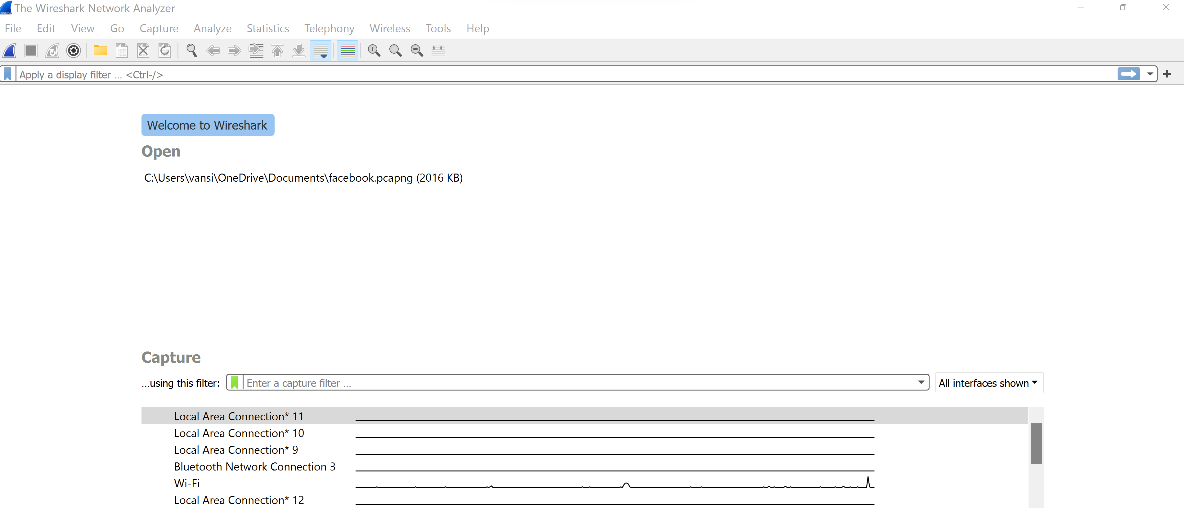

**Step-2: A capture filter was set to record only the TCP Traffic from tcp port 443 and save that capture file. Following is the capture filter written to do so.**

tcp port 443

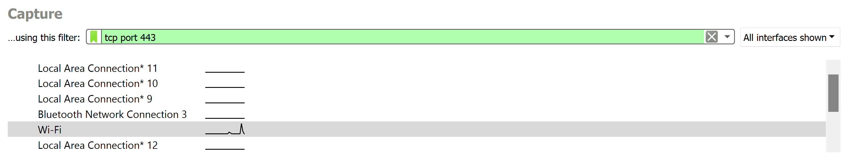

**Step-3 Facebook.com was logged into and the capture was started, after successfully logging in, the capture was stopped and the capture file was saved as “wstask1img1.** **pcapng"**

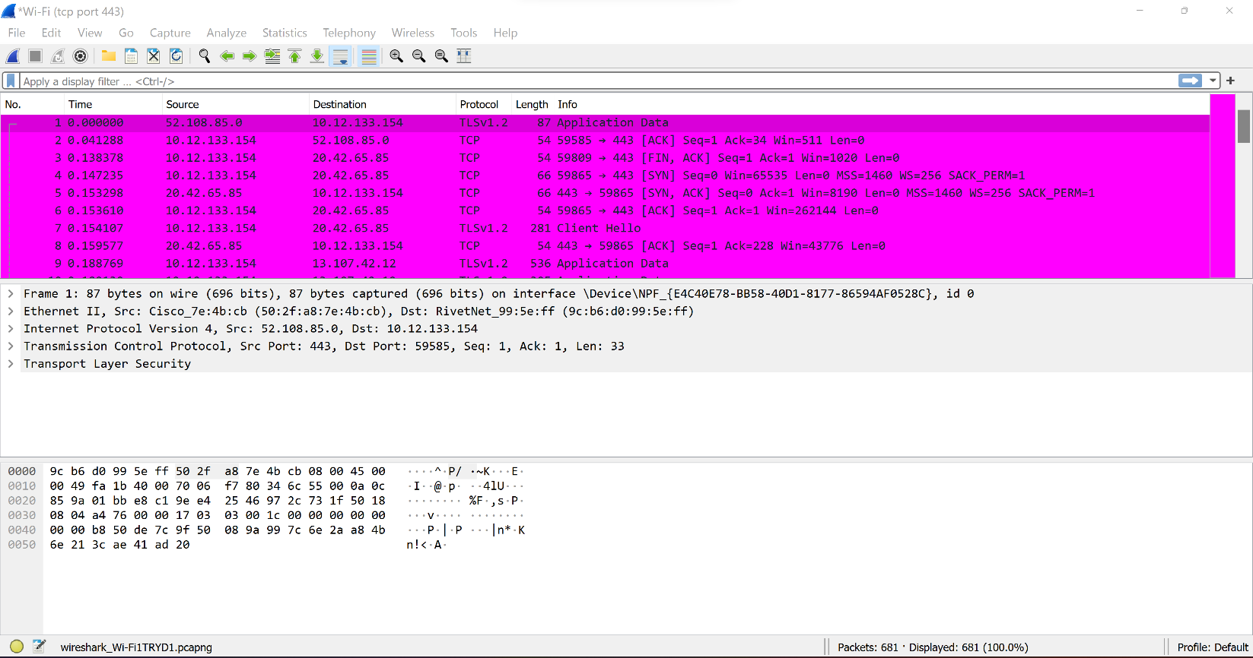

**As it can be seen in the status bar, 681 packets were captured in a total of 12.527 seconds.**

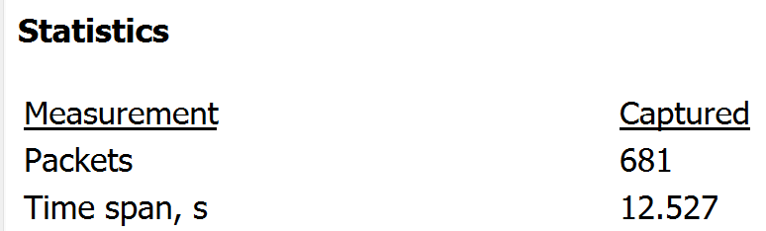

**Step-4: The following filter was applied to see how many were received from Facebook (157.240.23.11). Saved the file as "ip157.240.23.11R.pcapng".**

ip.dst==157.240.23.11

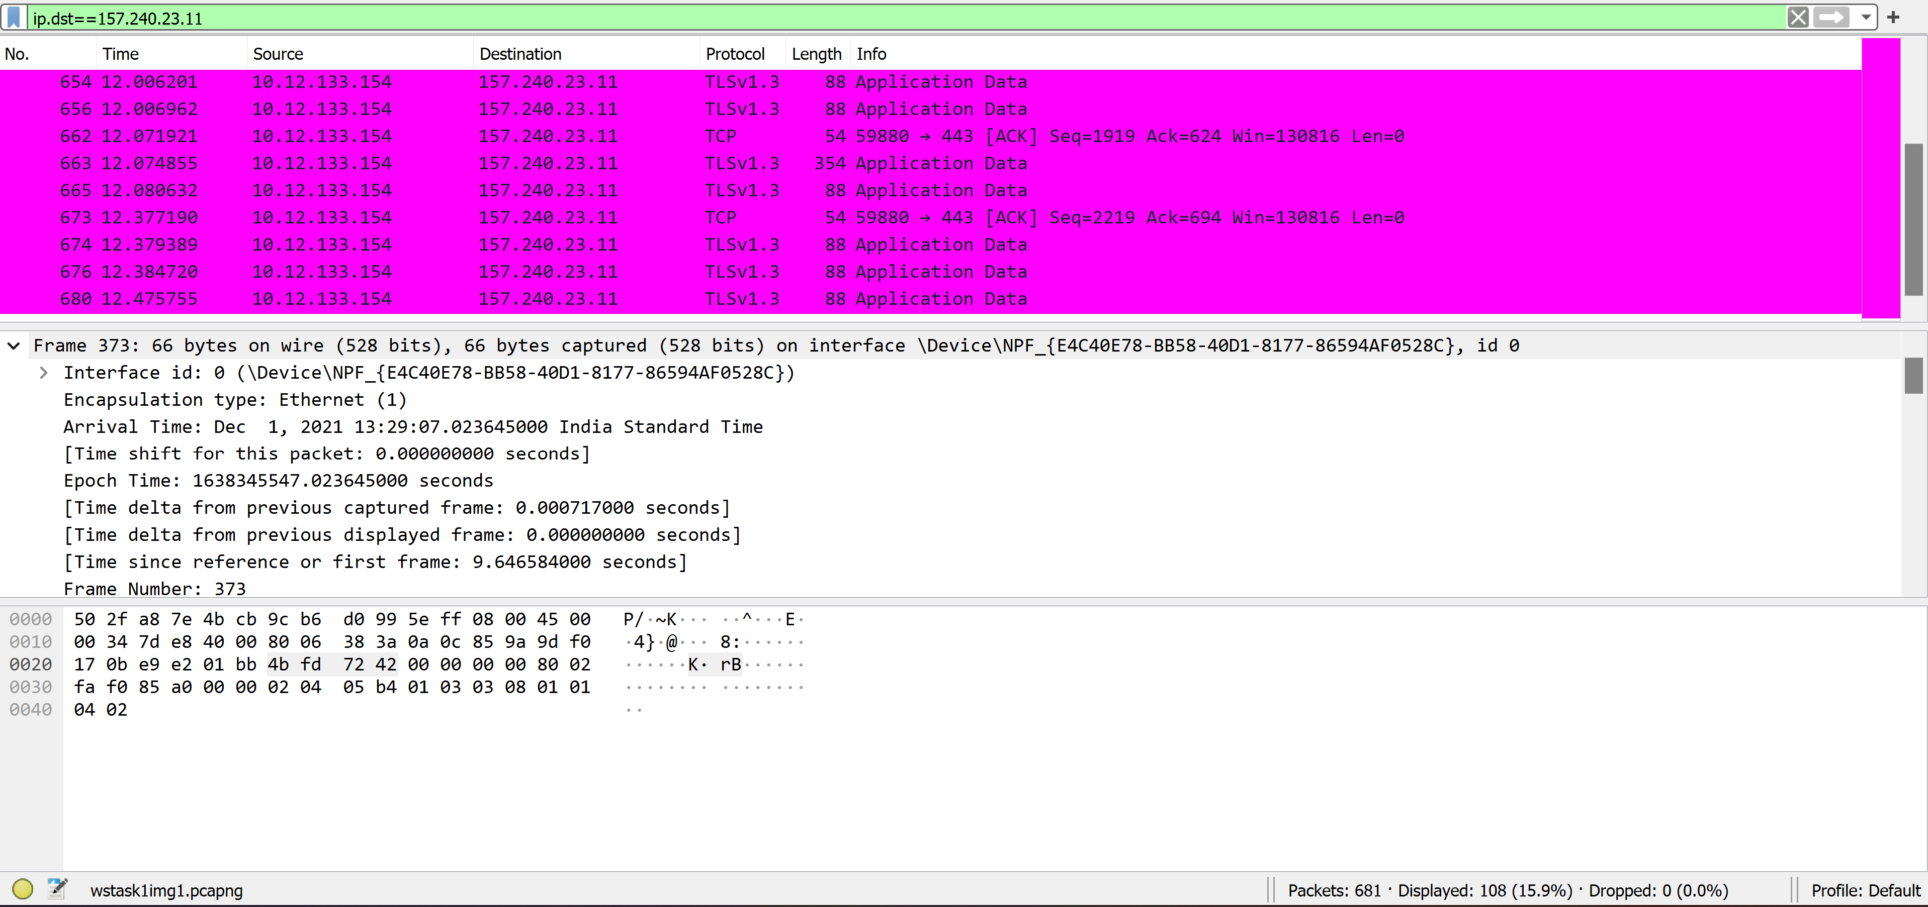

**As it can be seen in the status bar, a total of 108 packets were received from Facebook.**

**Step-5: The following filter was applied to see how many packets were sent to the machine (10.12.133.154). Saved the file as "ip10.12.133.154S.pcapng".**

ip.dst==10.12.133.154

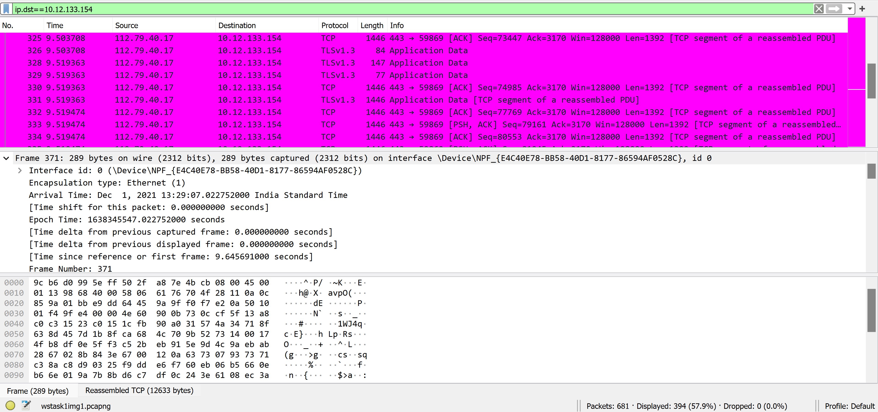

**As it can be seen in the status bar, a total of 394 packets were sent to our machine.**

**A ratio close to 4:1 can be observed from the packets received to that of sent.**

**Step-6- Display filters were then written to analyze the flags set in the captured packets. In order to determine the number of TCP packets with SYN flag set, the following display filter was written :**

tcp.flags.syn==1

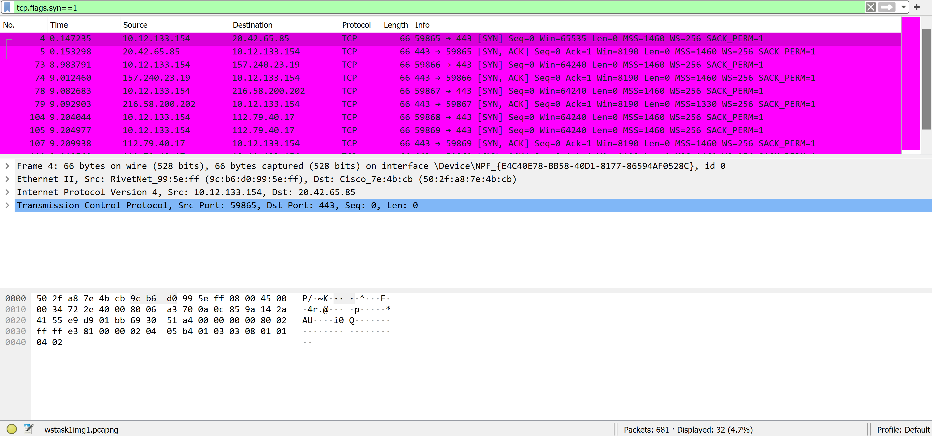

**As it can be seen the number of packets with SYN Flag set were 32. The file was saved as “task1synflag.pcapng”.**

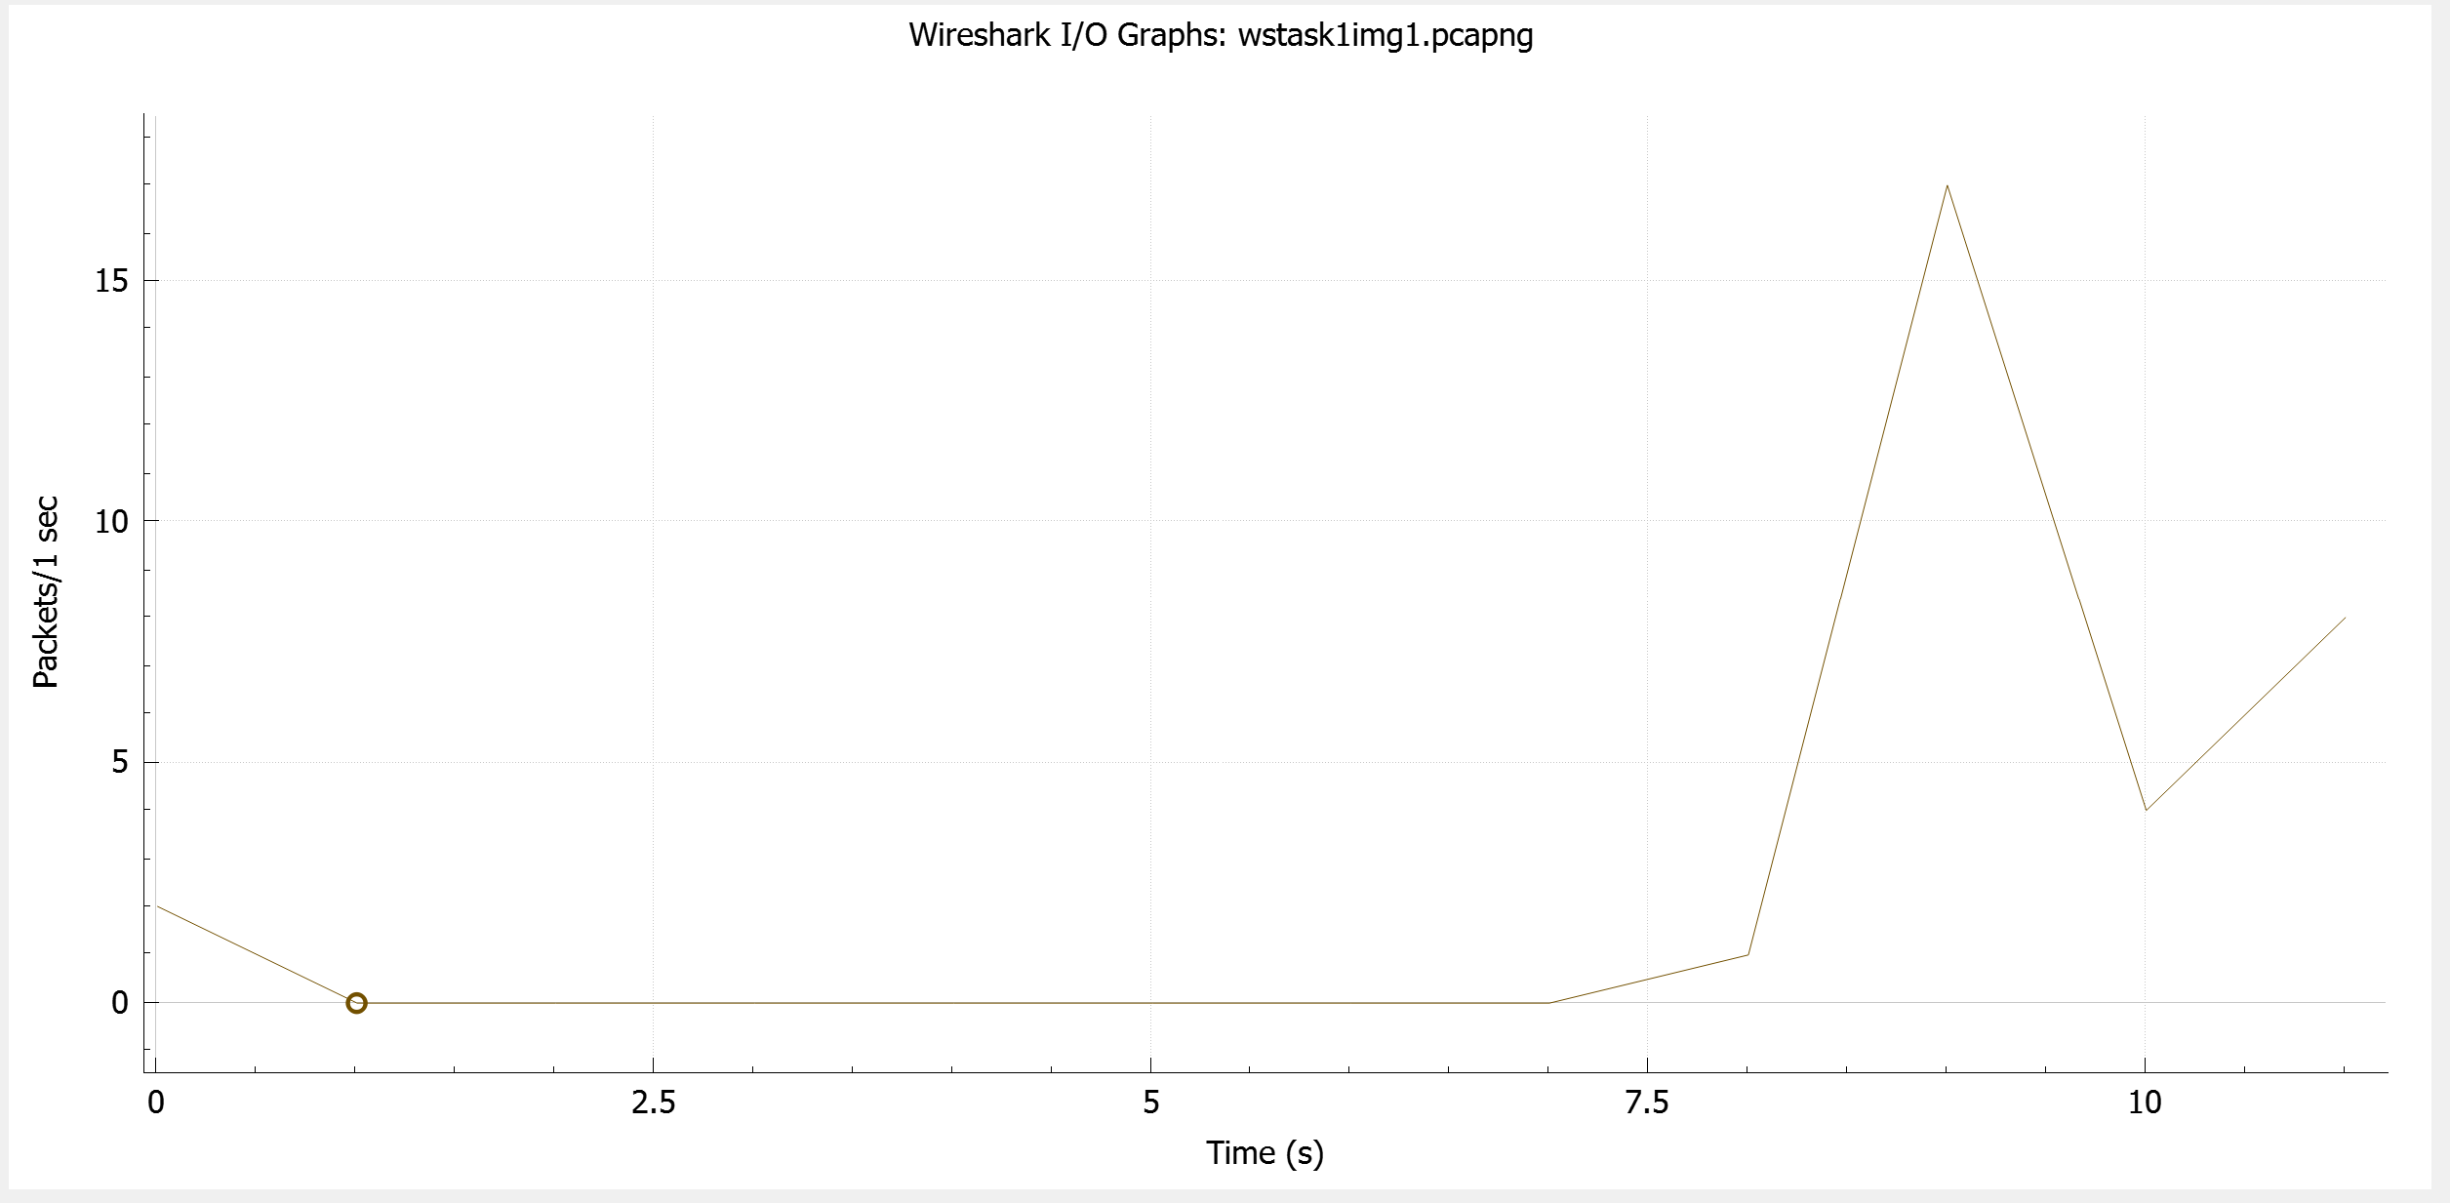

**Step-7:** **In order to determine the number of TCP packets with SYN flag not set, the following display filter was written:**

tcp.flags.syn==0

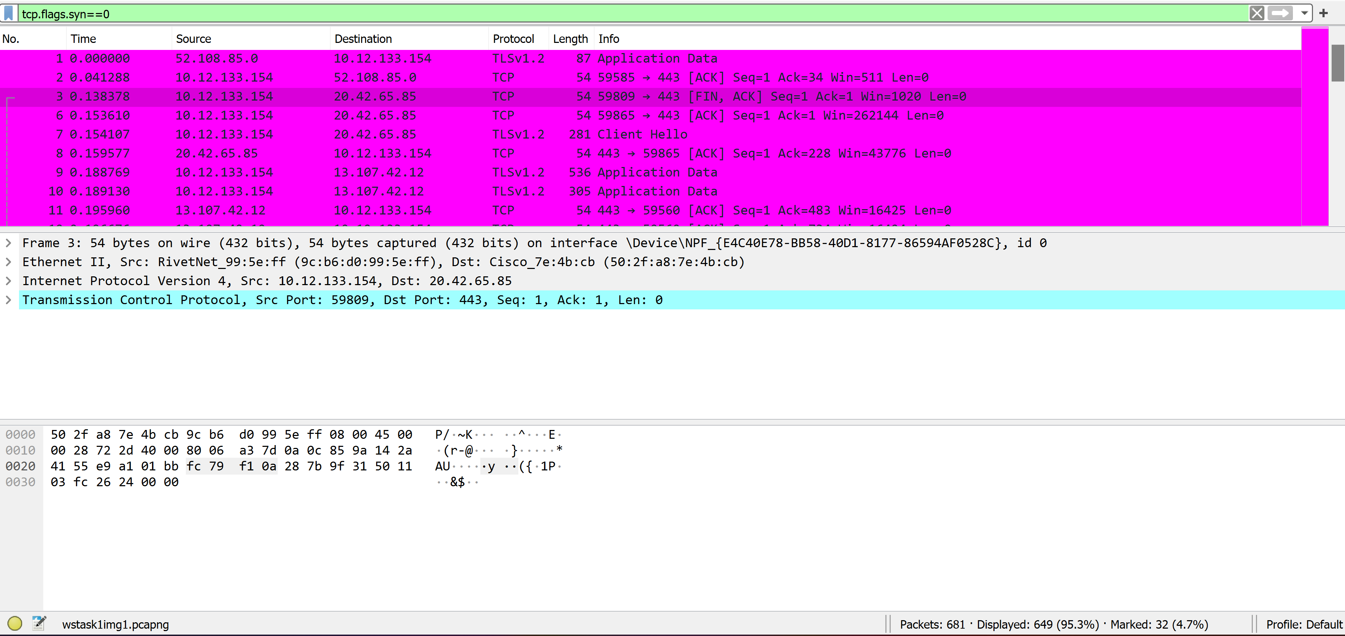

**As it can be seen the number of packets with SYN Flag not set were 649. The file was saved as “task1notsynflag.pcapng”.**

**Step-8: In order to determine the number of TCP packets with SYN flag set and sent to host, the following display filter was written:**

tcp.flags.syn==1 && ip.dst==10.12.133.154

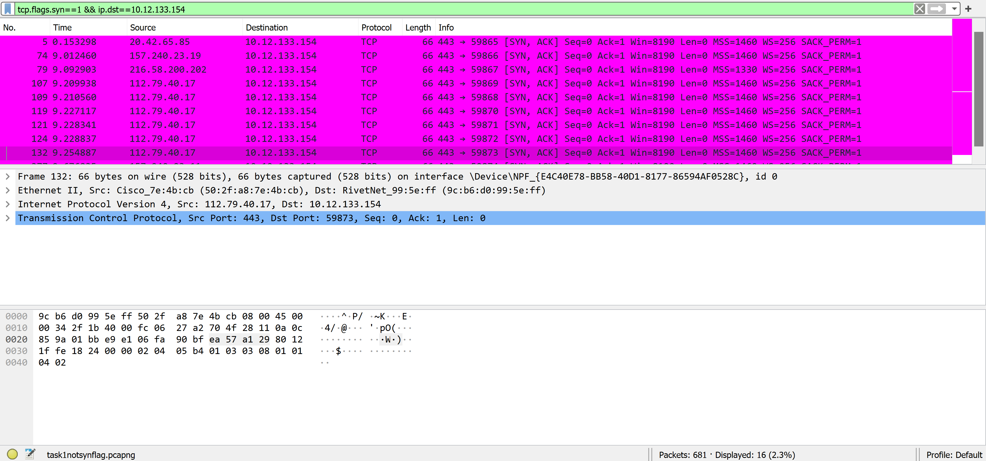

**As it can be seen the number of packets with SYN Flag set and sent to host were 16. The file was saved as “task1hostsynflag.pcapng”.**

**Step-9: In order to determine the number of TCP packets with SYN flag set and sent to Facebook, the following display filter was written:**

tcp.flags.syn==1 && ip.dst==157.240.23.11

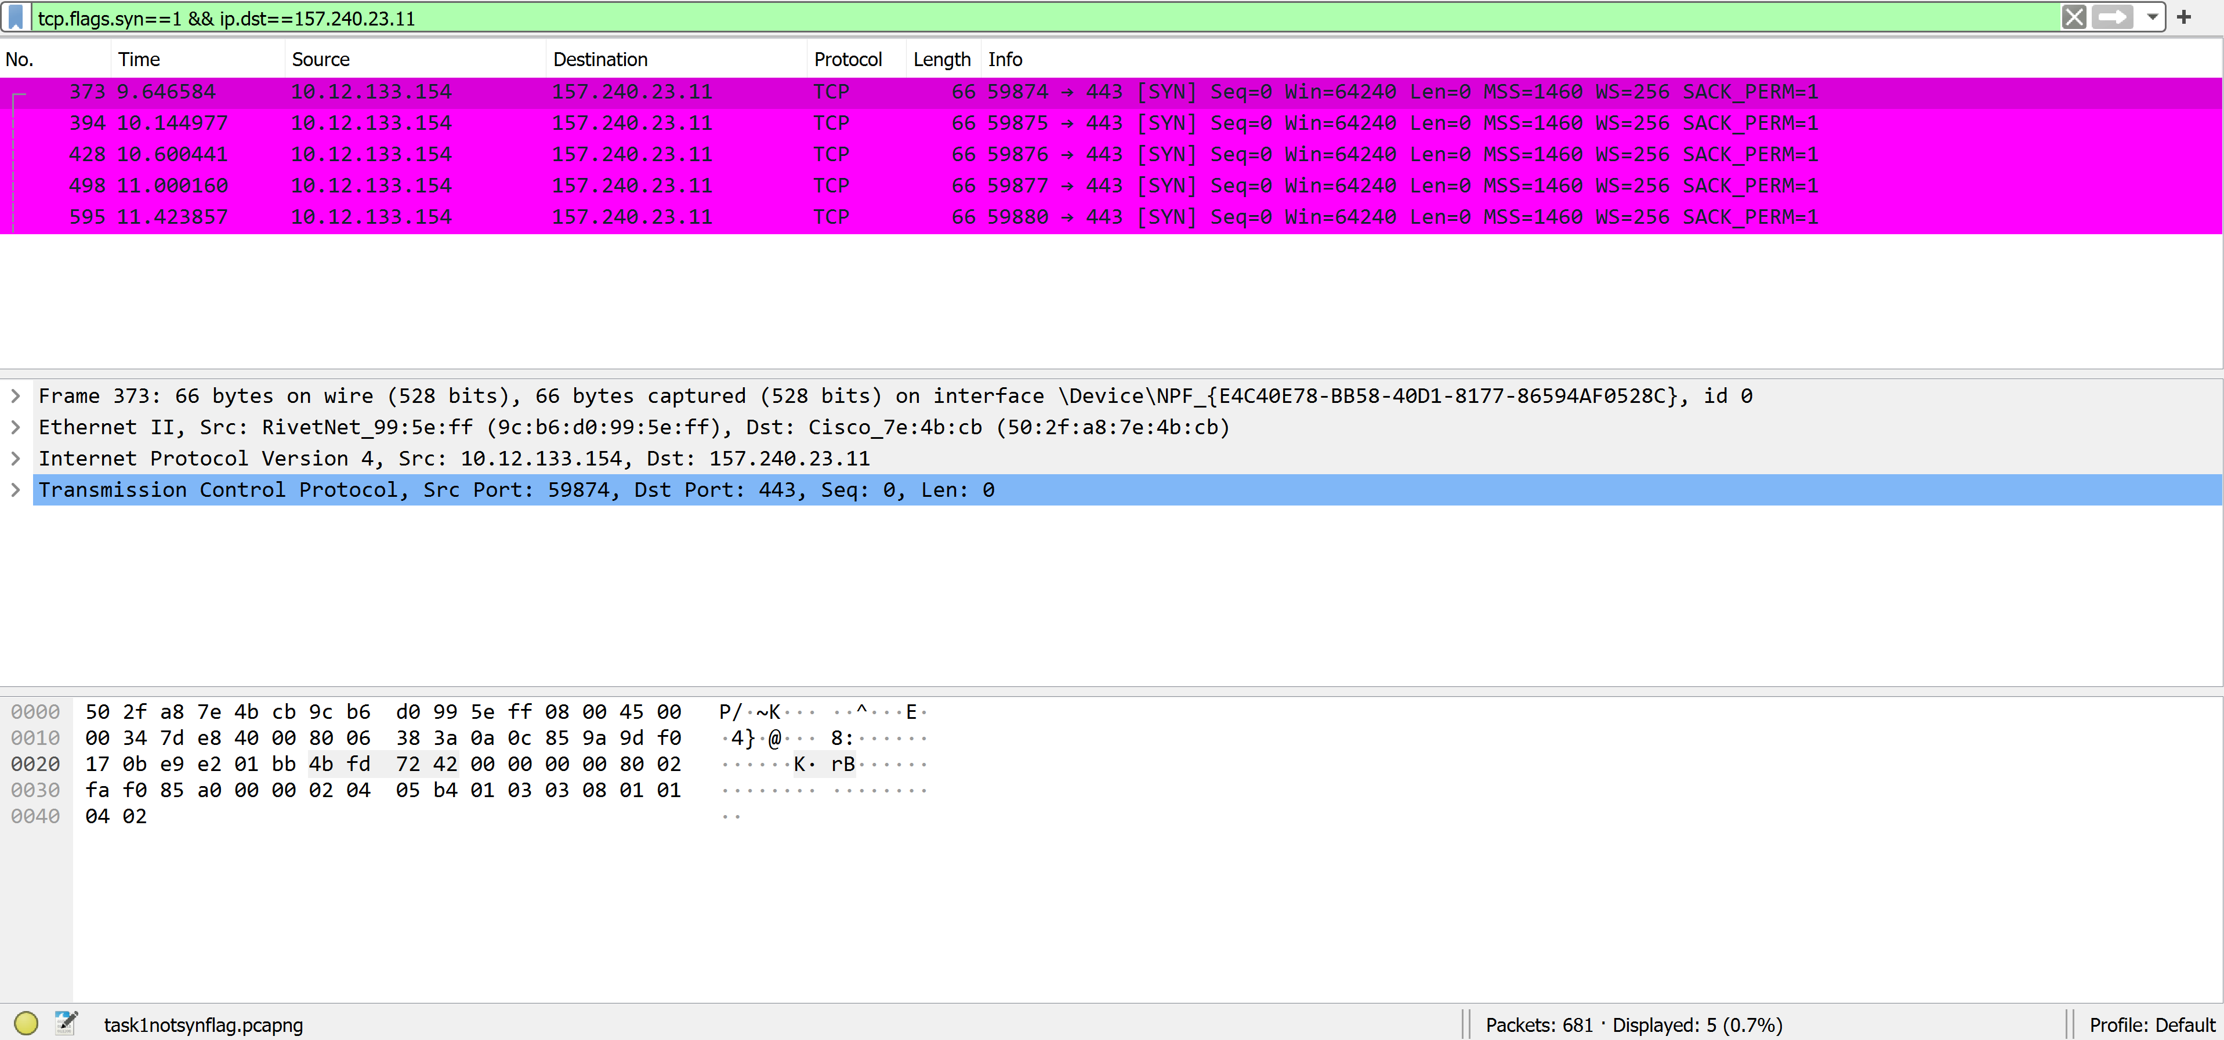

**As it can be seen the number of packets with SYN Flag set and sent to Facebook were 5. The file was saved as “task1facebooksynflag.pcapng”.**

**Step-10: In order to determine the number of TCP packets with PSH flag set, the following display filter was written:**

tcp.flags.push==1

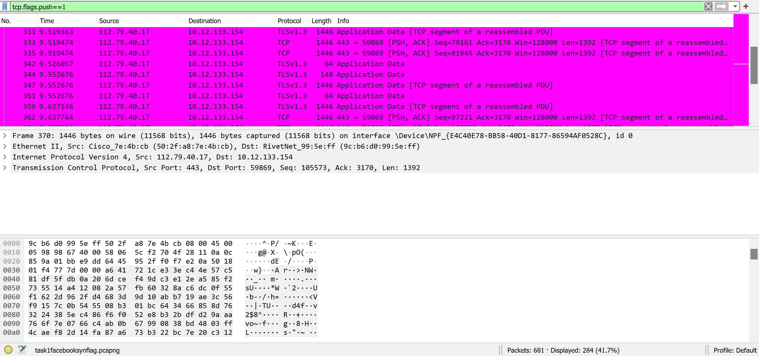

**As it can be seen the number of packets with PSH Flag set 284. The file was saved as “task1pshflag.pcapng”.**

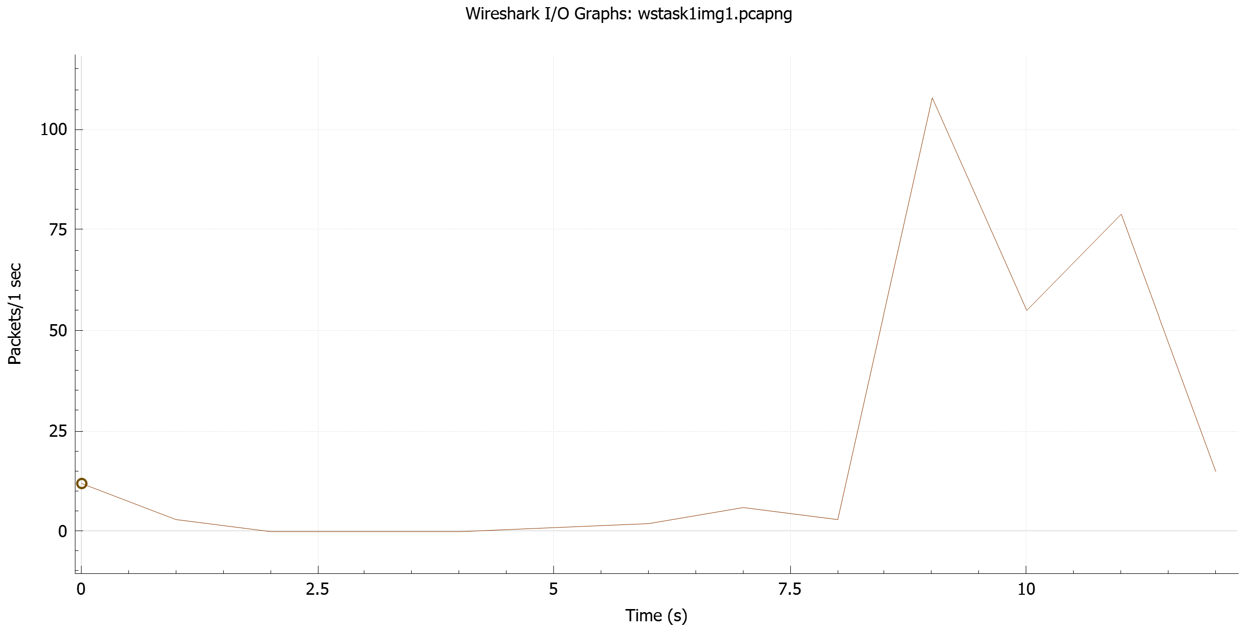

**Step-11: In order to determine the number of TCP packets with PSH flag not set, the following display filter was written:**

tcp.flags.push==0

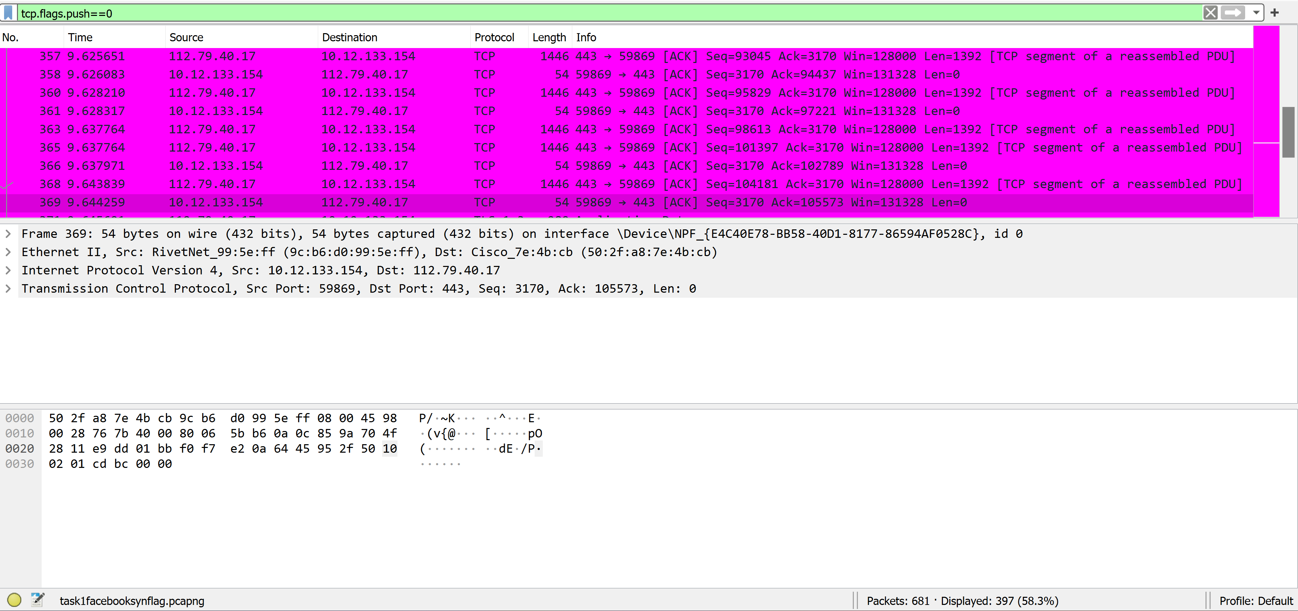

**As it can be seen the number of packets with PSH Flag not set 397. The file was saved as “task1notpshflag.pcapng”.**

**Step-12: In order to determine the number of TCP packets with PSH flag set and sent to host, the following display filter was written:**

tcp.flags.push==1 && ip.dst==10.12.133.154

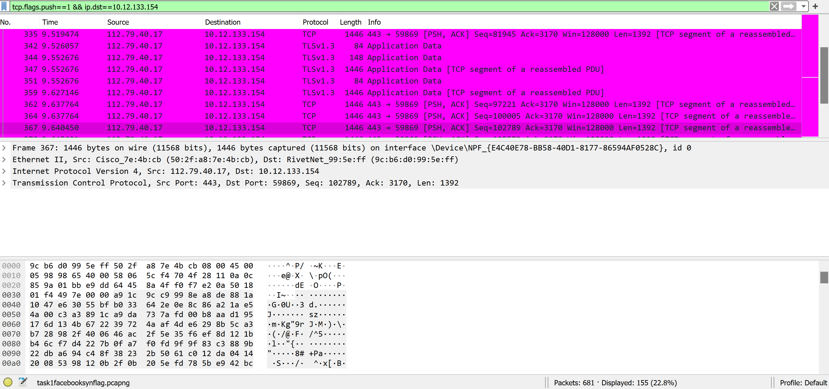

**As it can be seen the number of packets with PSH Flag set and sent to host 155. The file was saved as “task1hostpshflag.pcapng”.**

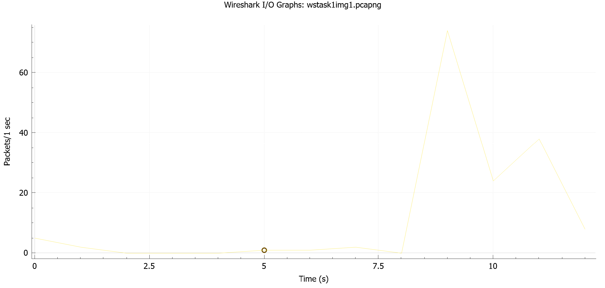

**Step-13: In order to determine the number of TCP packets with PSH flag set and sent to Facebook, the following display filter was written:**

tcp.flags.push==1 && ip.dst==157.240.23.11

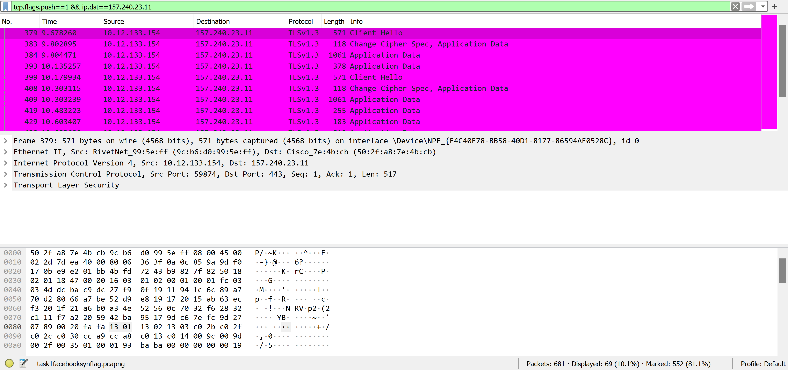

**As it can be seen the number of packets with PSH Flag set and sent to Facebook 69. The file was saved as “task1facebookpshflag.pcapng”.**

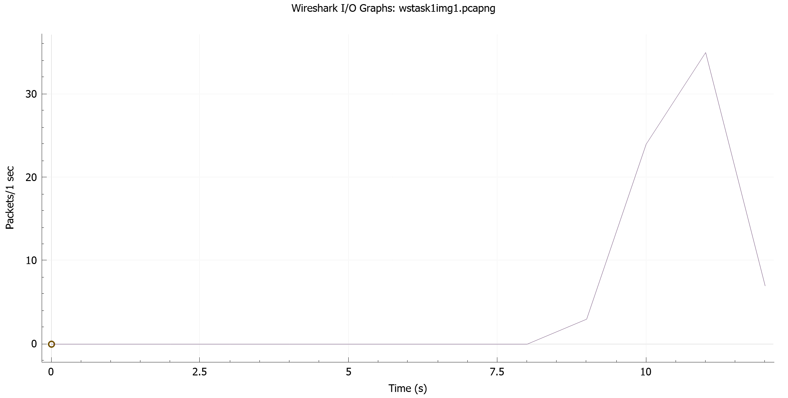

**Step-14: In order to determine the number of TCP packets with PSH flag or SYN flag set and sent to host, the following display filter was written:**

(tcp.flags.push==1||tcp.flags.syn==1) &&

ip.dst==10.12.133.154

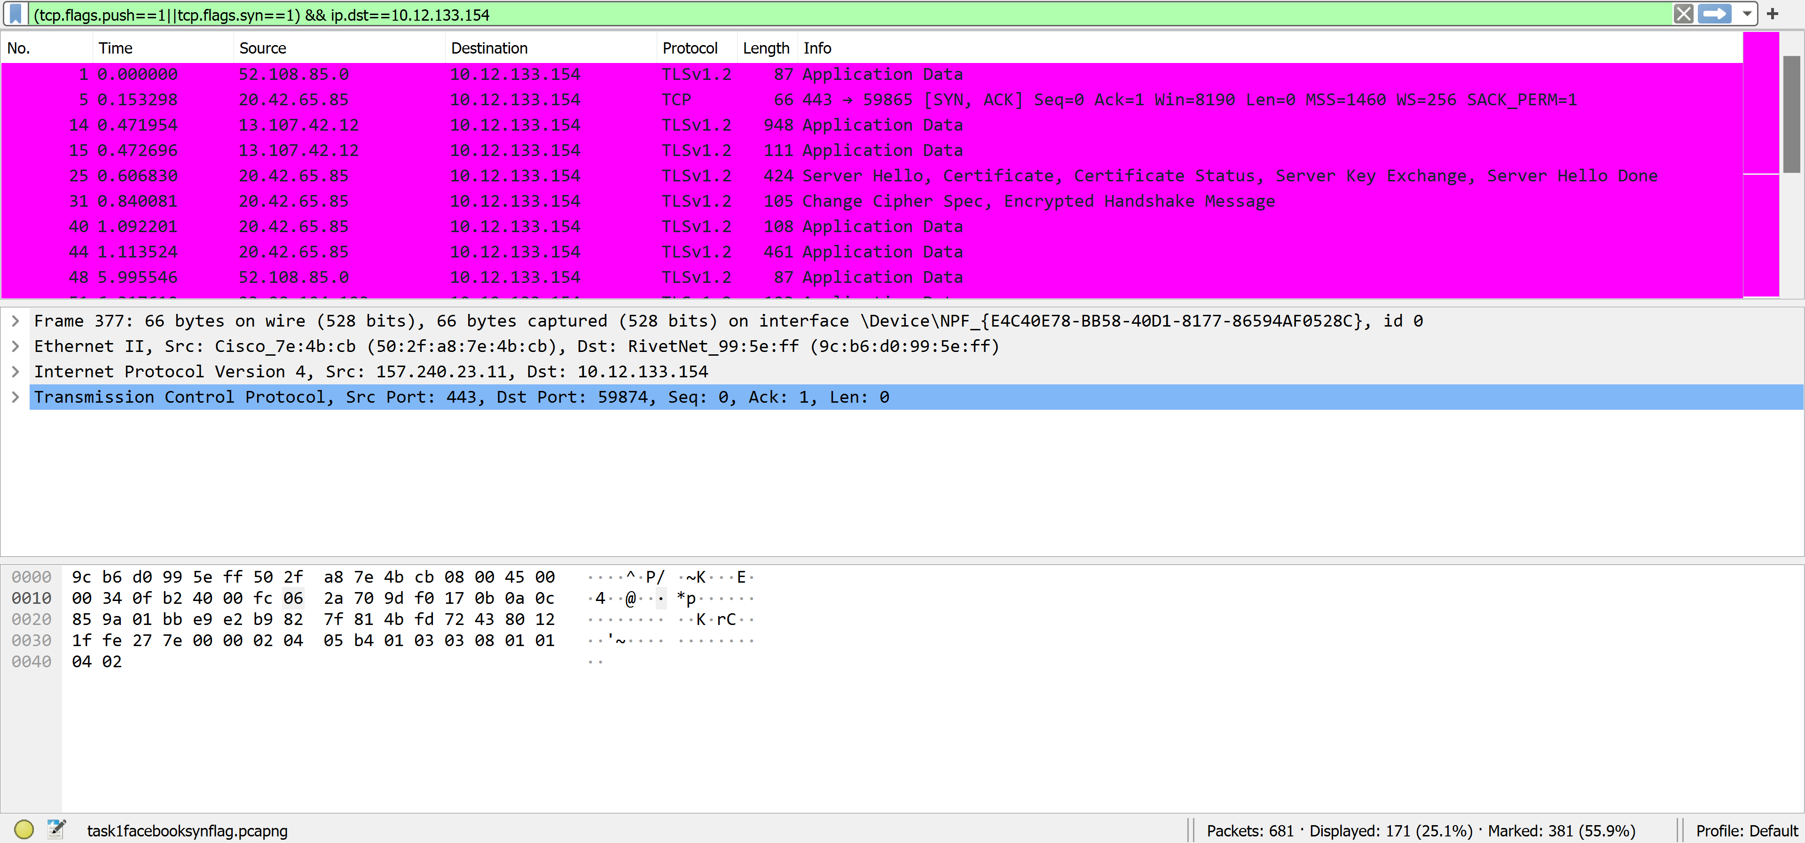

**As it can be seen the number of packets with PSH Flag or SYN Flag set is 171. The file was saved as “task1hostsynorpshflag.pcapng”.**

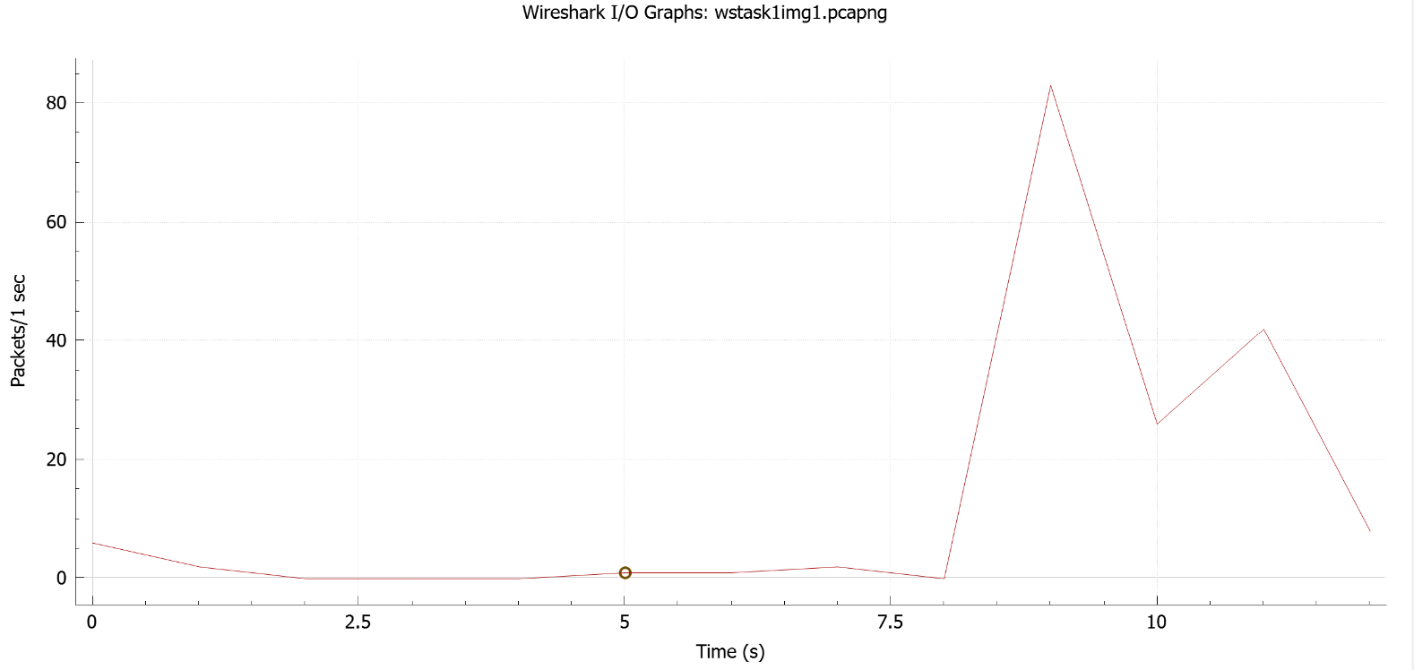

**Step-15: In order to determine the number of TCP packets with PSH flag or SYN flag set and sent to Facebook, the following display filter was written:**

(tcp.flags.push==1||tcp.flags.syn==1) &&

ip.dst==157.240.23.11

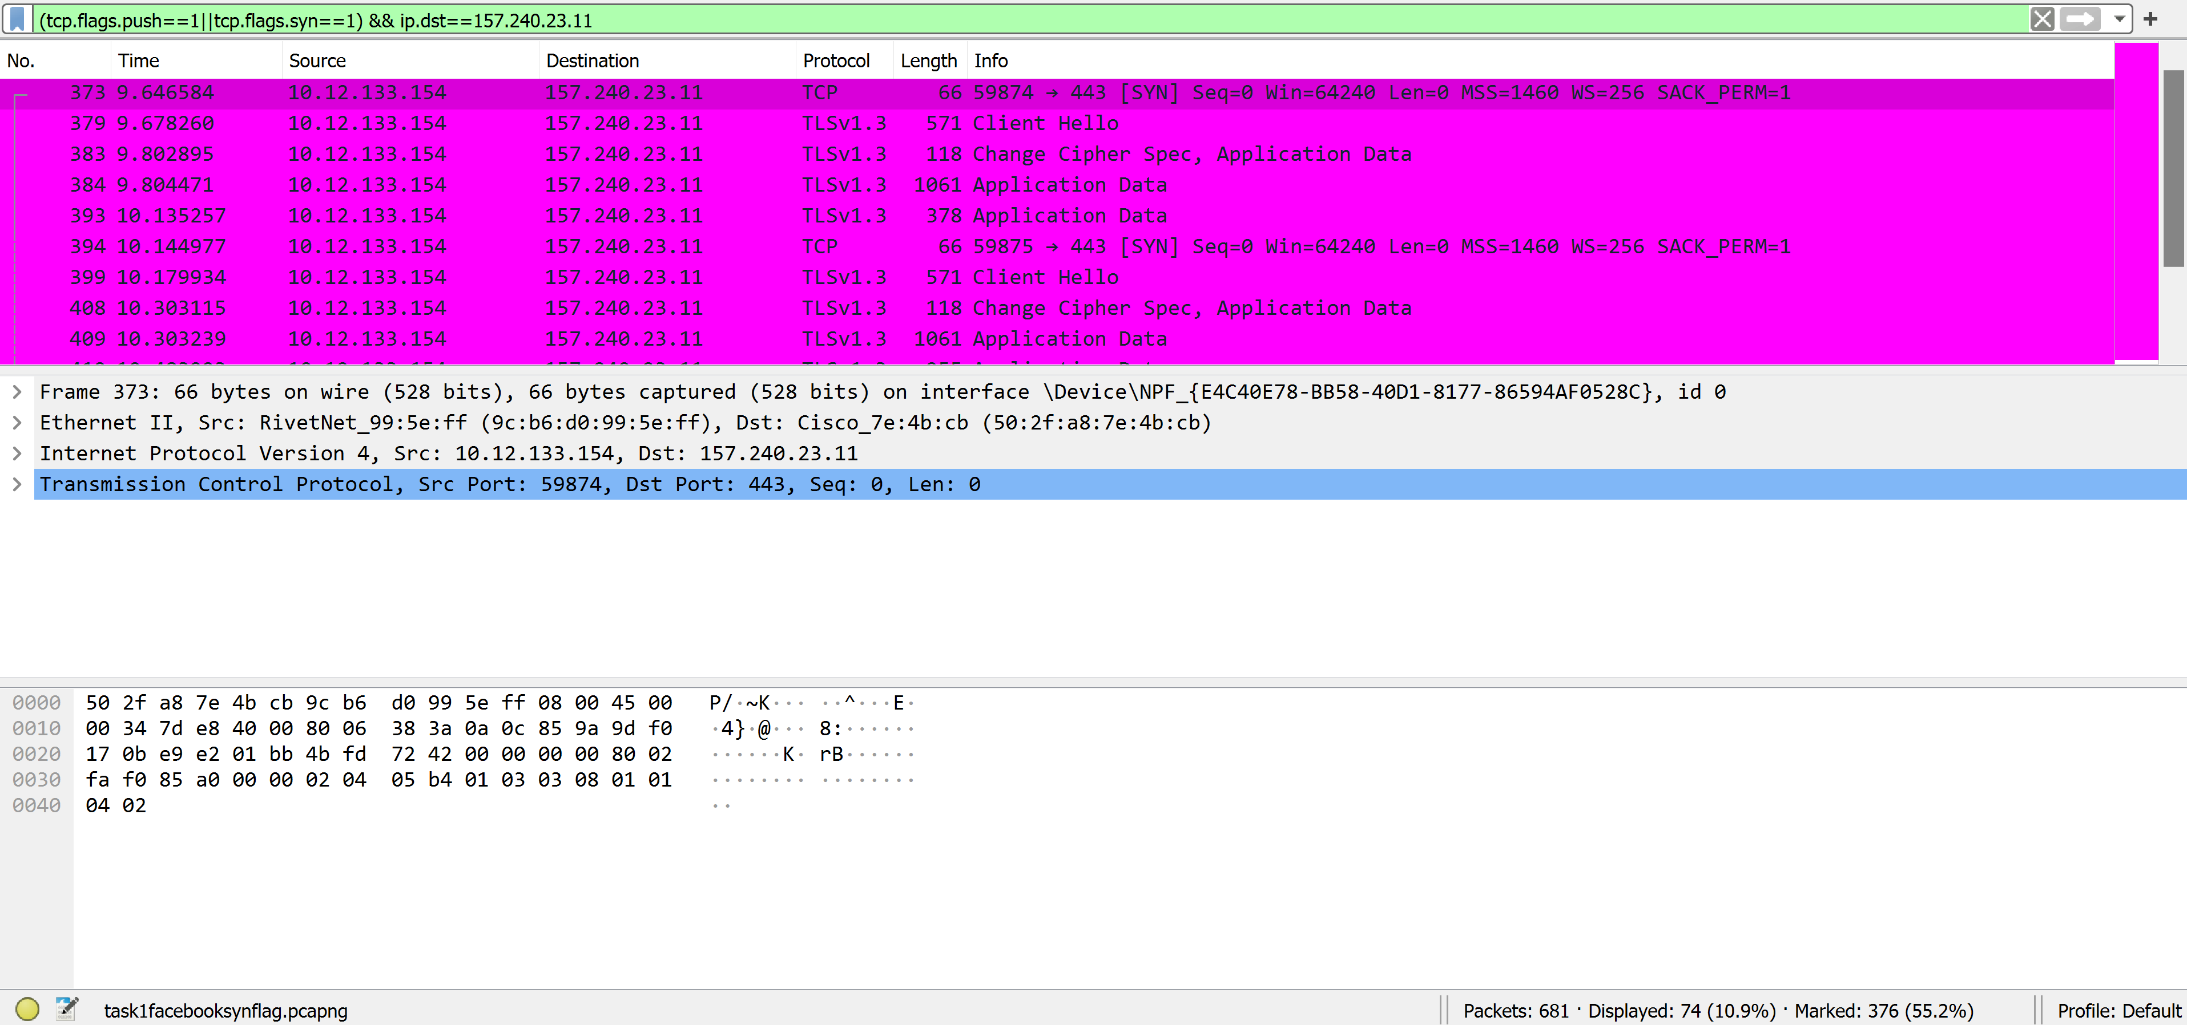

**As it can be seen the number of packets with PSH Flag or SYN Flag set and sent to Facebook is 74. The file was saved as “task1facebooksynorpshflag.pcapng”.**

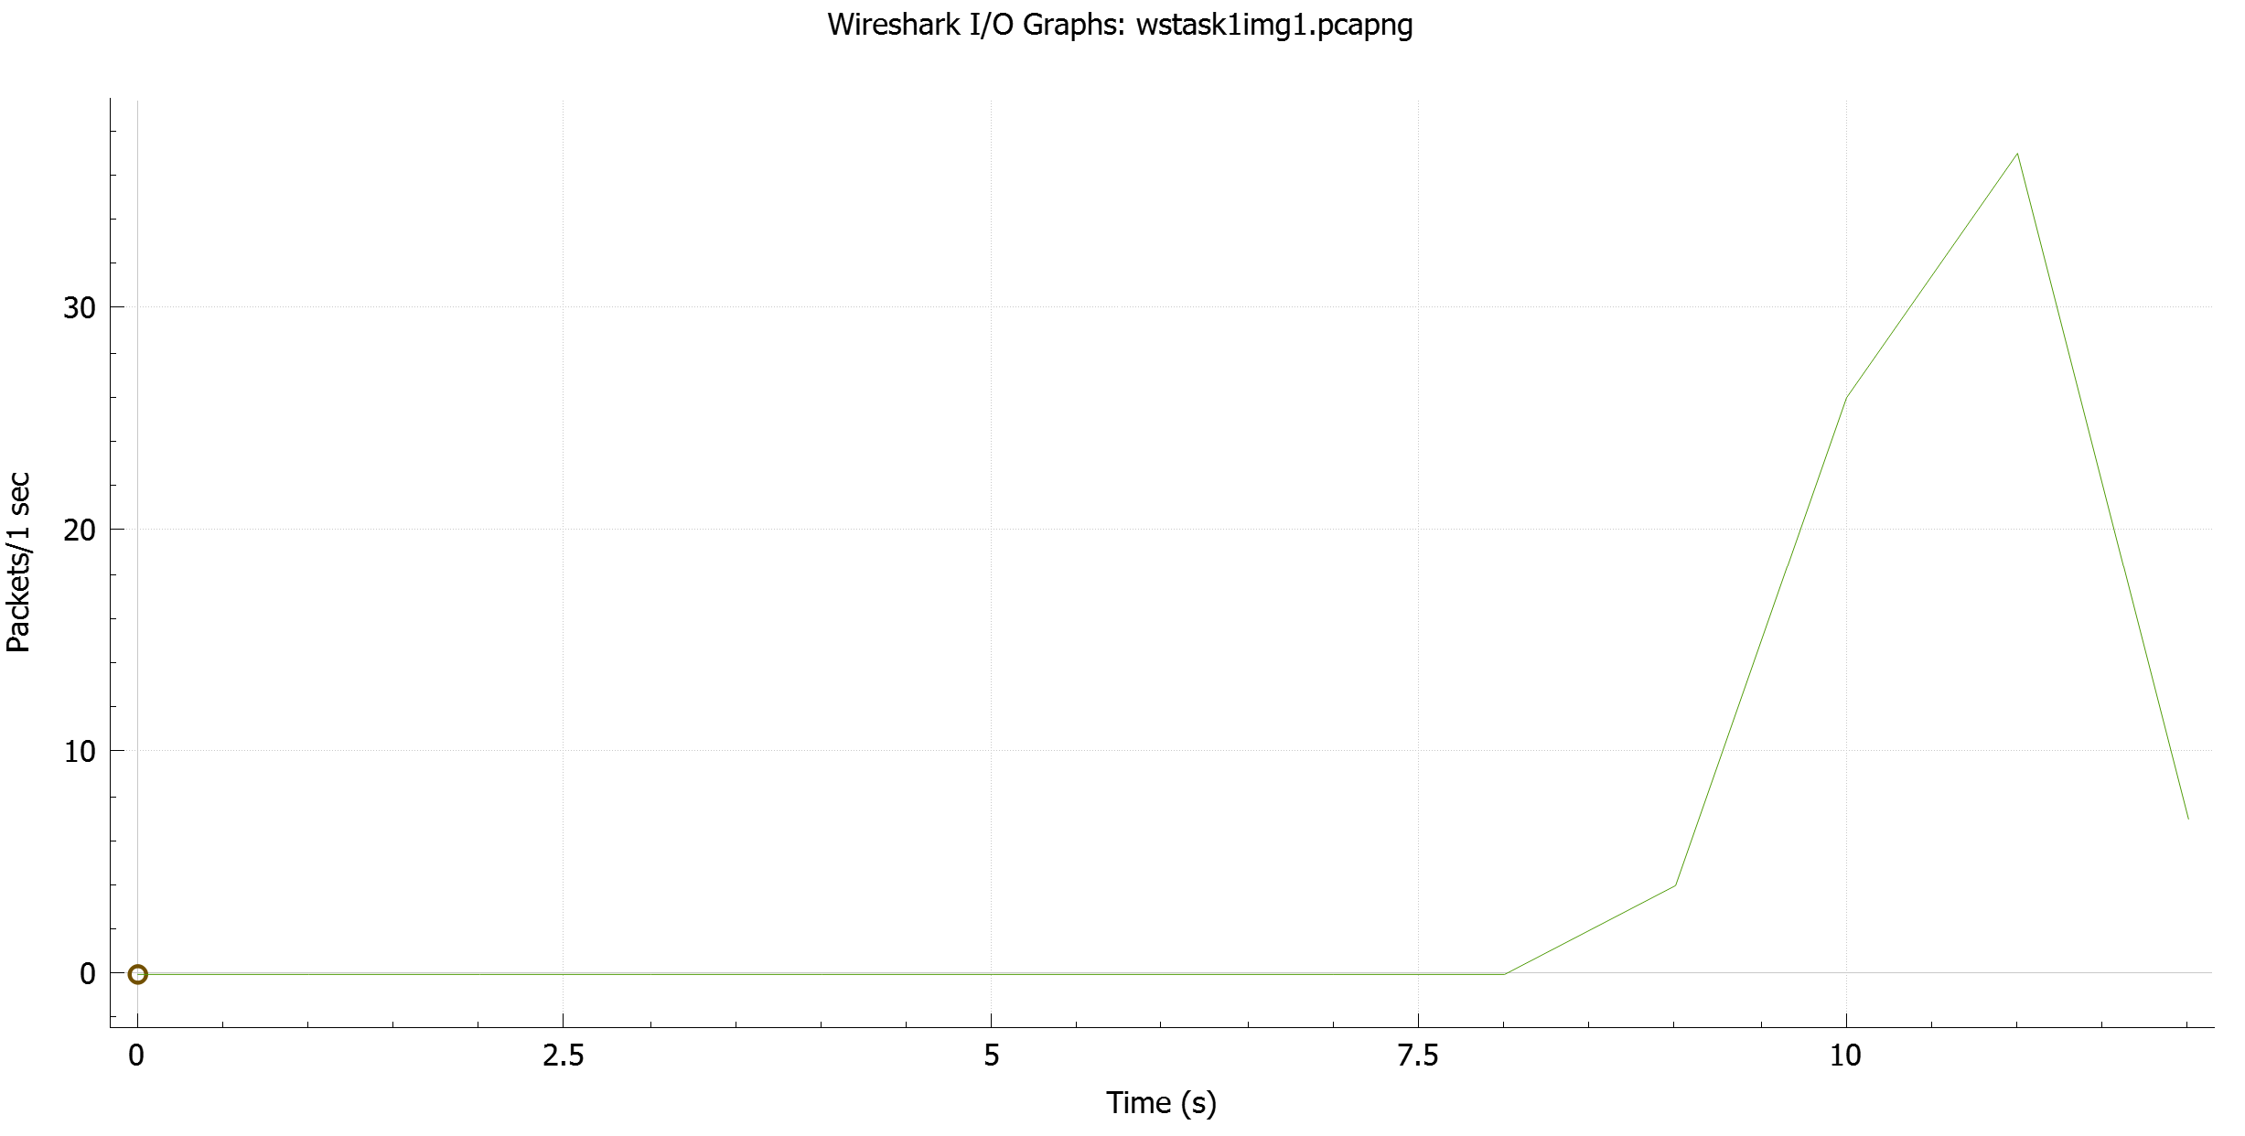

**Step-16: In order to determine the number of TCP packets with RST flag set, the following display filter was written:**

tcp.flags.reset==1

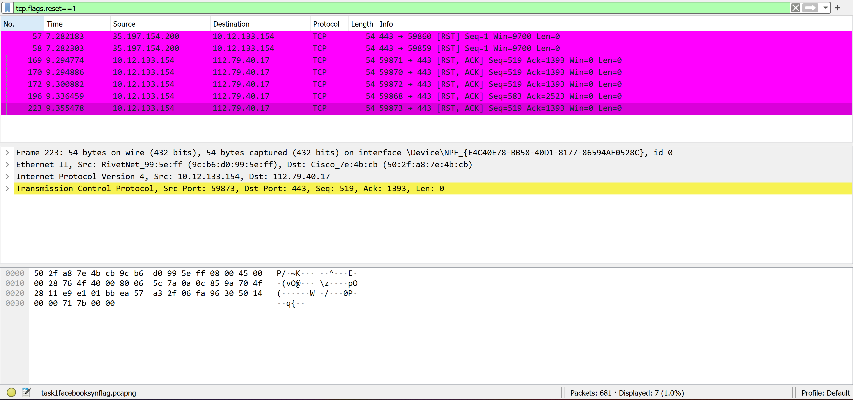

**As it can be seen the number of packets with RST Flag set is 7. The file was saved as “task1rstflag.pcapng”.**

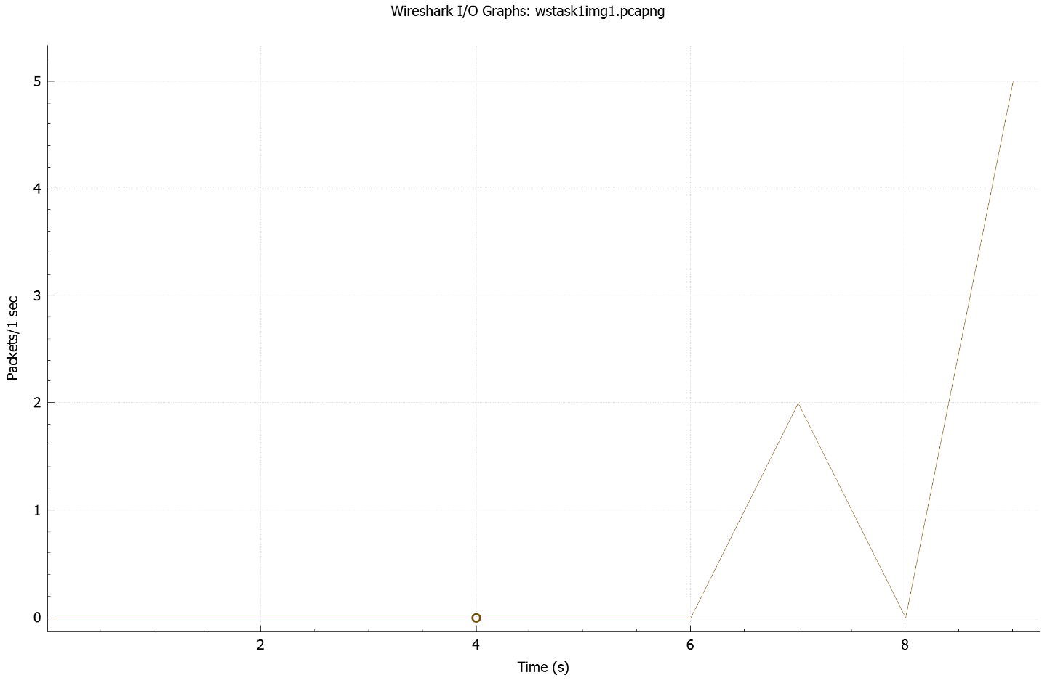

**Step-16: In order to determine the number of TCP packets with RST flag not set, the following display filter was written:**

tcp.flags.reset==0

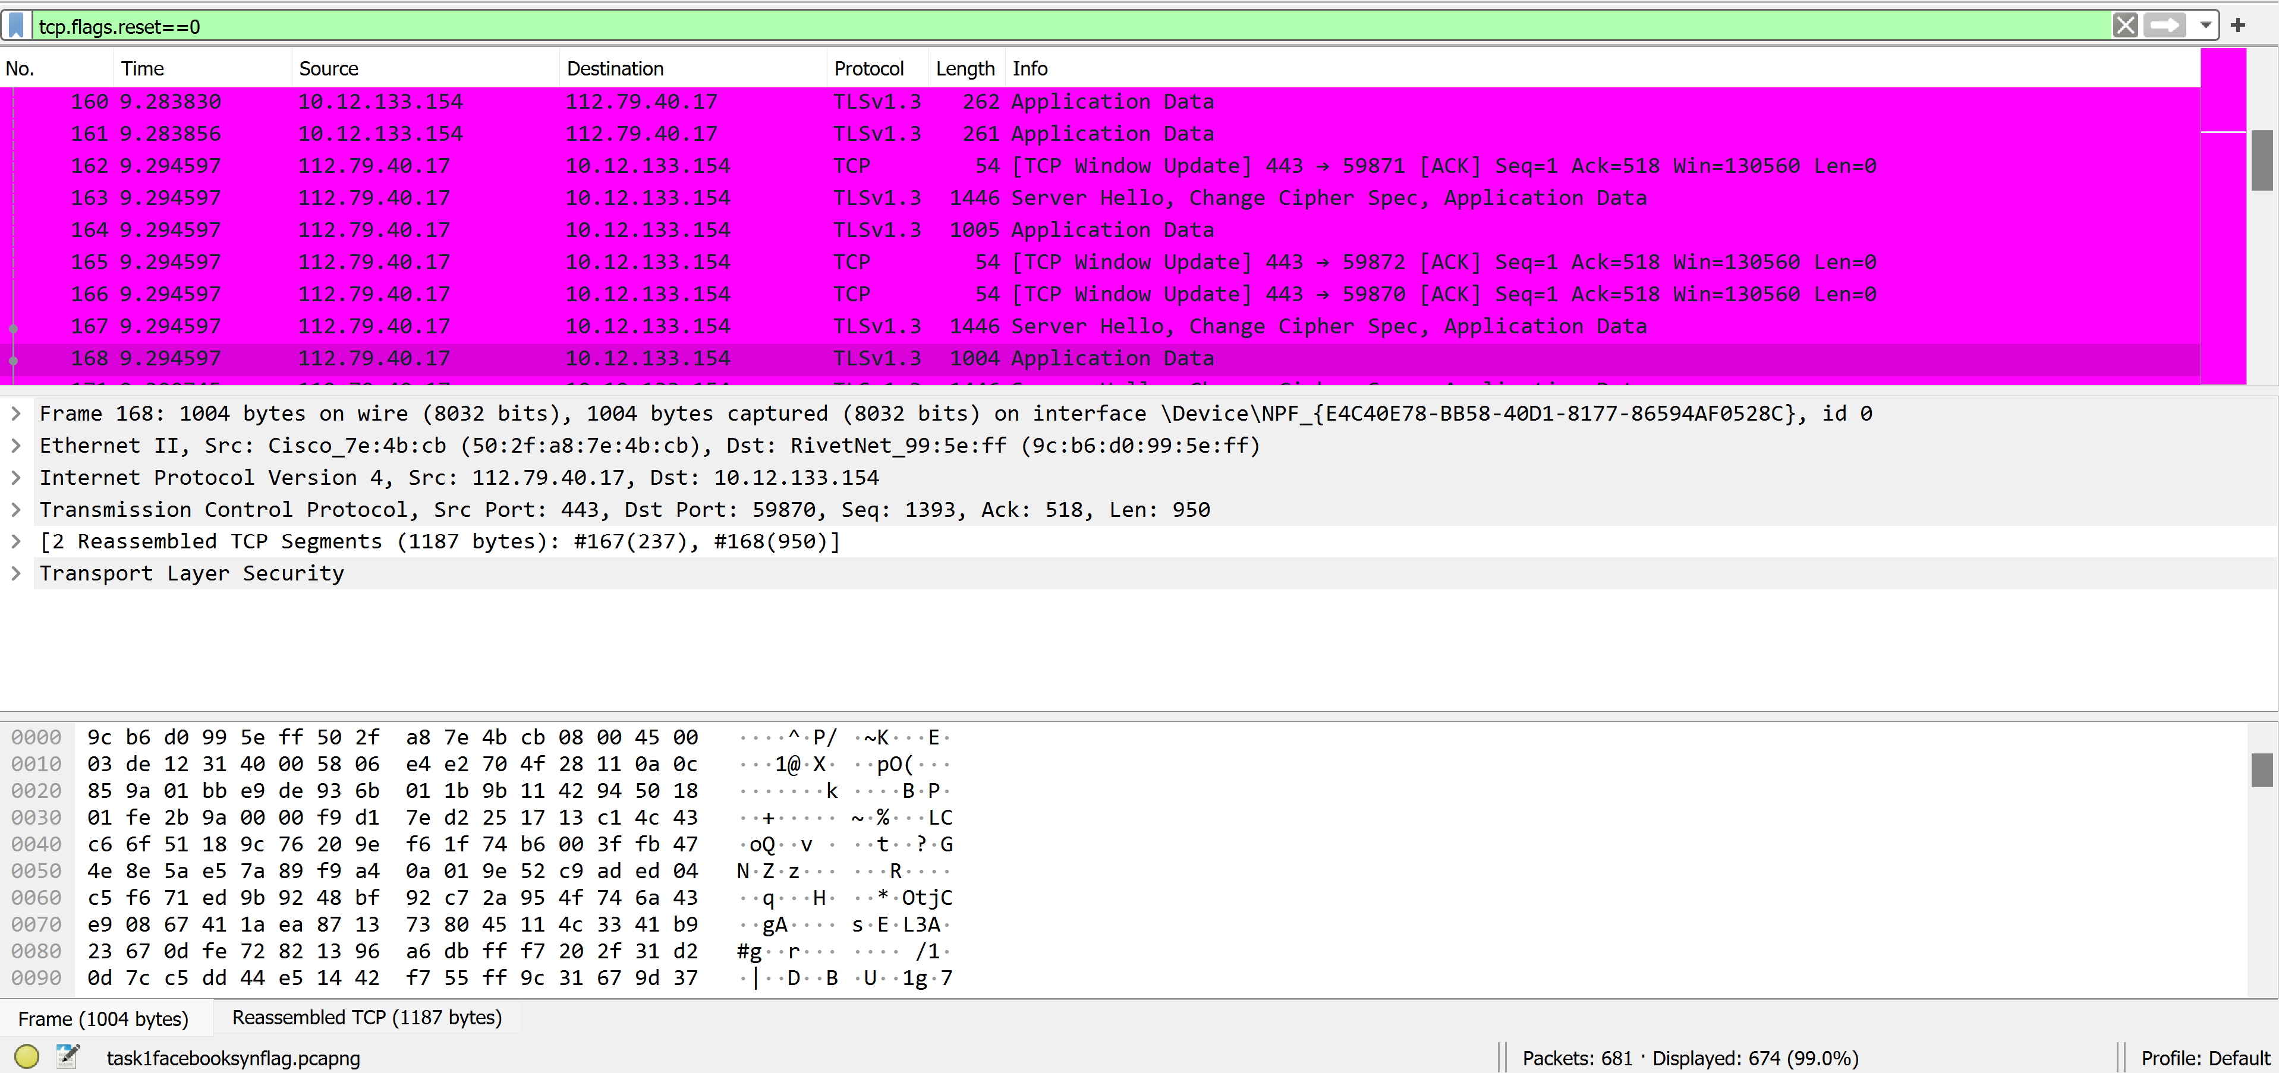

**As it can be seen the number of packets with RST Flag set is 674. The file was saved as “task1notrstflag.pcapng”.**

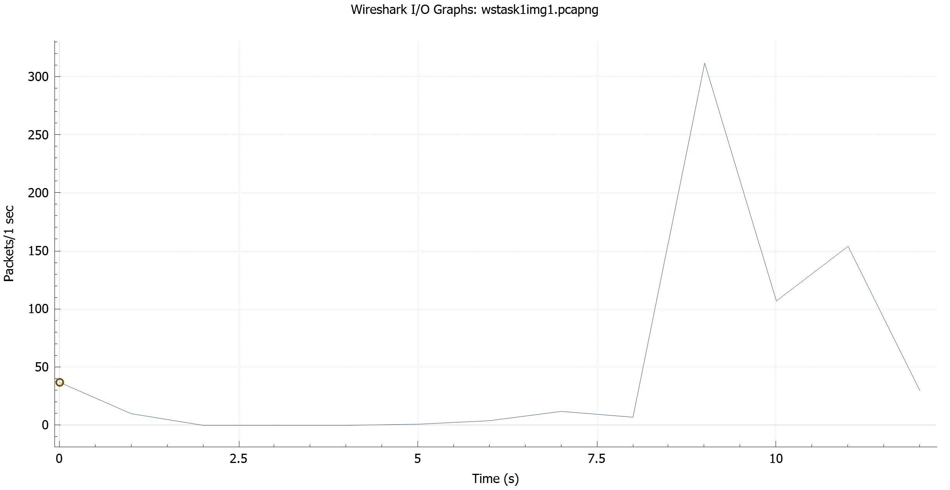

**Table-1: Summary of Analysis**

|  |  |
| --- | --- |
| **Captured TCP Packets Flags Statistics** | |
| **Task: Capture all TCP traffic to/from Facebook, while logging in to Facebook account.** | |
| Total Captured Packets | **681** |
| Packets Sent to Facebook | **394** |
| Packets Received from Facebook | **108** |
| Packets Sent to Facebook with SYN flag set | **5** |
| Packets Sent to Facebook with PSH flag set | **69** |
| Packets Received from Facebook with SYN flag set | **16** |
| Packets Received from Facebook with PSH flag set | **155** |
| Packets Sent to Facebook with SYN & PSH flags set | **74** |
| Packets Received from Facebook with SYN & PSH flags set | **171** |
| Total Packets with SYN flag set | **32** |
| Total Packets with PSH flag set | **284** |
| Total Packets with RST flag set | **7** |
| Total Packets with ACK flag set | **663** |
| Total Packets with CWR flag set | **0** |
| Total Packets with SYN and PSH flags set | **0** |

**Experiment-2**

**Step-1: A YouTube video** <https://www.youtube.com/watch?v=TYMMOjBUPMM&ab_channel=JakeSmith> **was played on youtube.com and the capture was started.**

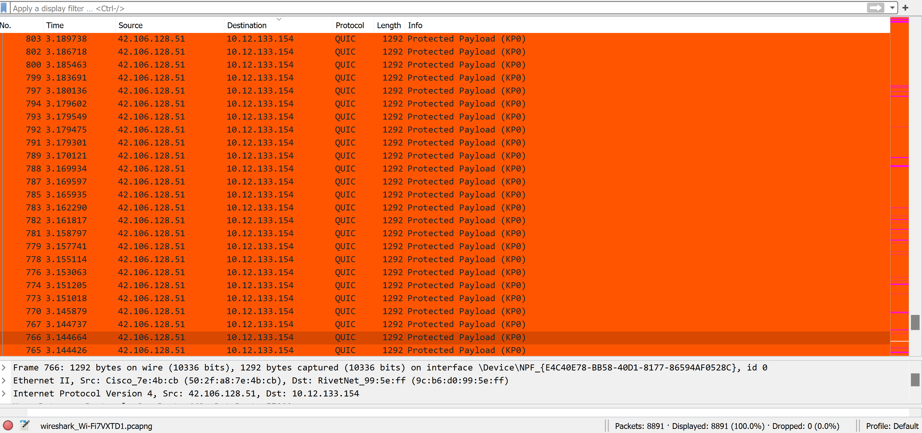

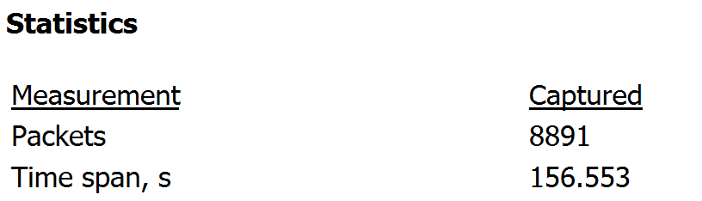

**As it can be seen in the statistics bar, a total of 8891 packets were captured in the duration of 156.553 seconds. The capture was saved as “task2youtube.pcapng”.**

**No capture filters were utilized as YouTube servers may change during streaming. Large amounts of traffic have been observed to IP** **42.106.128.51, but communication to YouTube isn’t limited to this single server. For the sake of calculation, only this IP was considered for the sake of calculating volume of transmitted traffic, but for other calculations (flags, etc.) the entire traffic is considered.**

**Step-2: To isolate the packets sent by host and received at YouTube, the following display filter was used:**

ip.src==10.12.133.154 and ip.dst==42.106.128.51

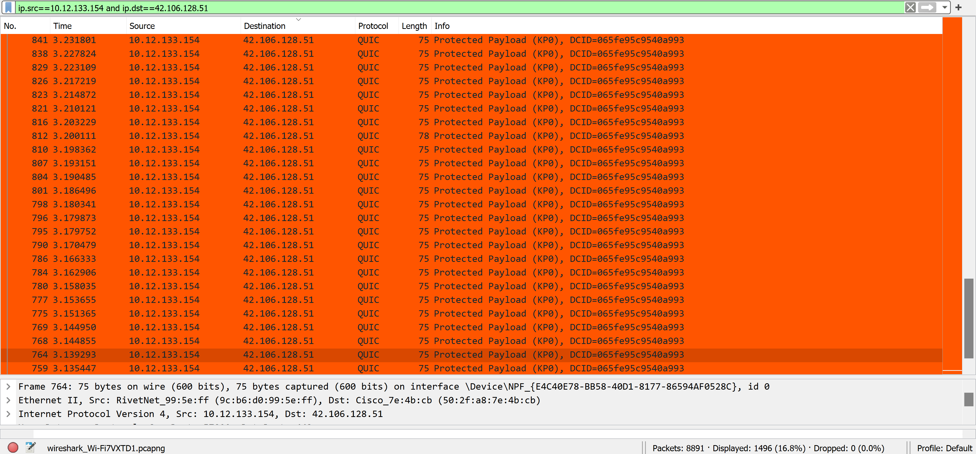

**As it can be seen a total of 1496/8891 packets were sent to YouTube. The capture file was saved as “task2sentyoutube.pcapng”.**

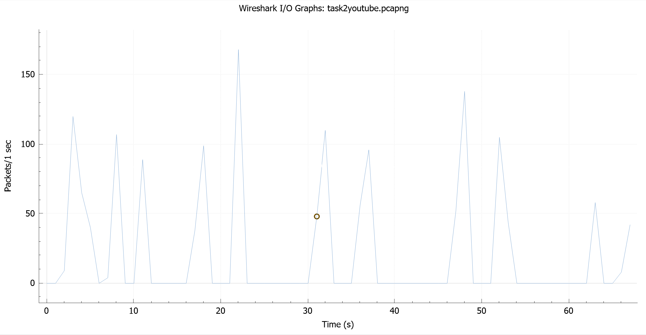

**Step-3: To isolate the packets sent by YouTube and Received by host the following display filter was used:**

ip.src==42.106.128.51 and ip.dst==10.12.133.154

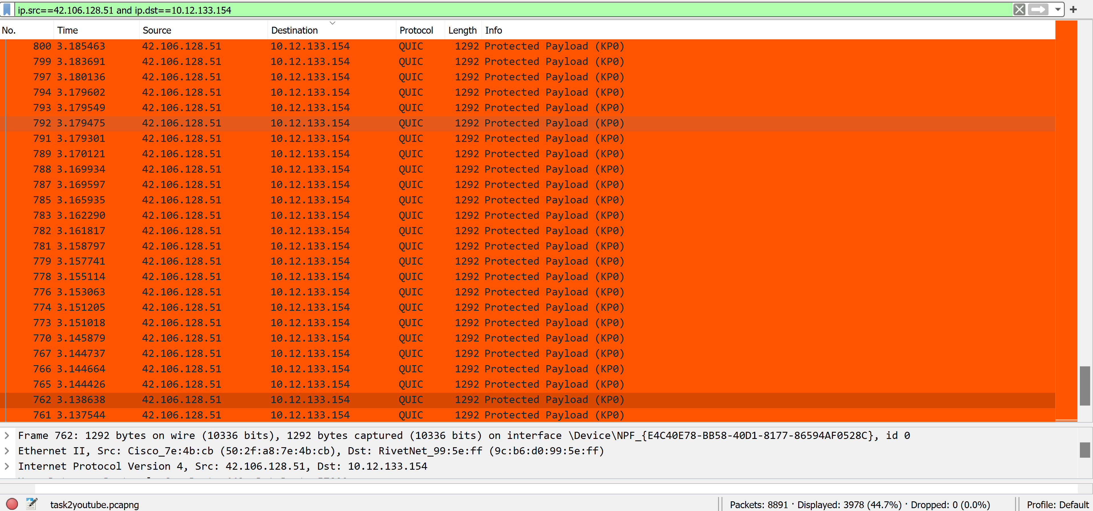

**As it can be seen, 3978/8891 packets were received by the host. The capture file was saved as “task2recievedyoutube.pcapng”.**

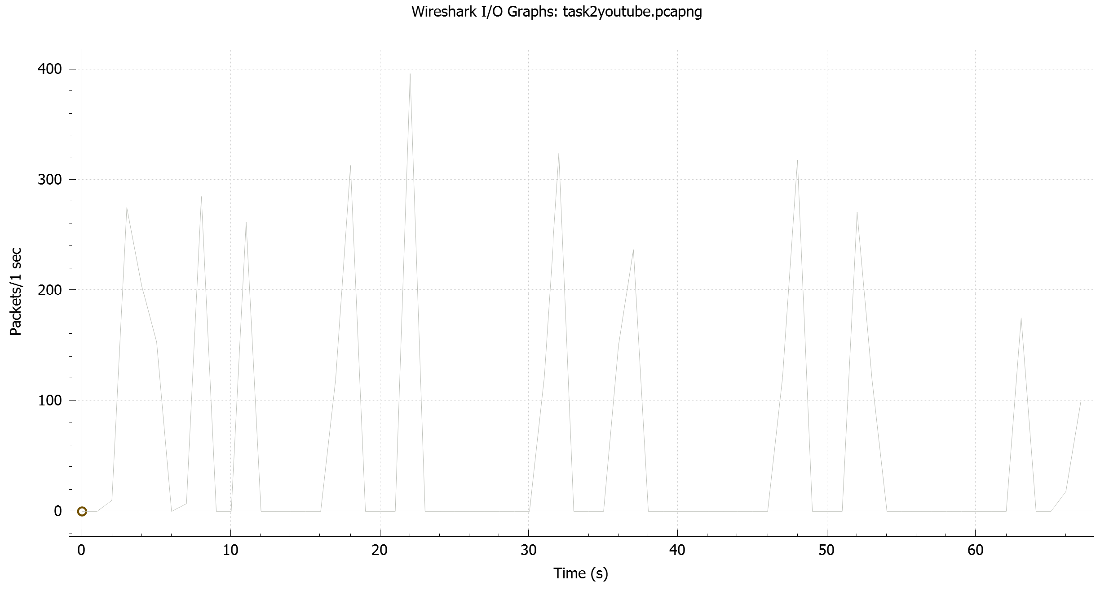

**Step-4: The number of packets that had SYN set was determined using the following filter:**

tcp.flags.syn==1

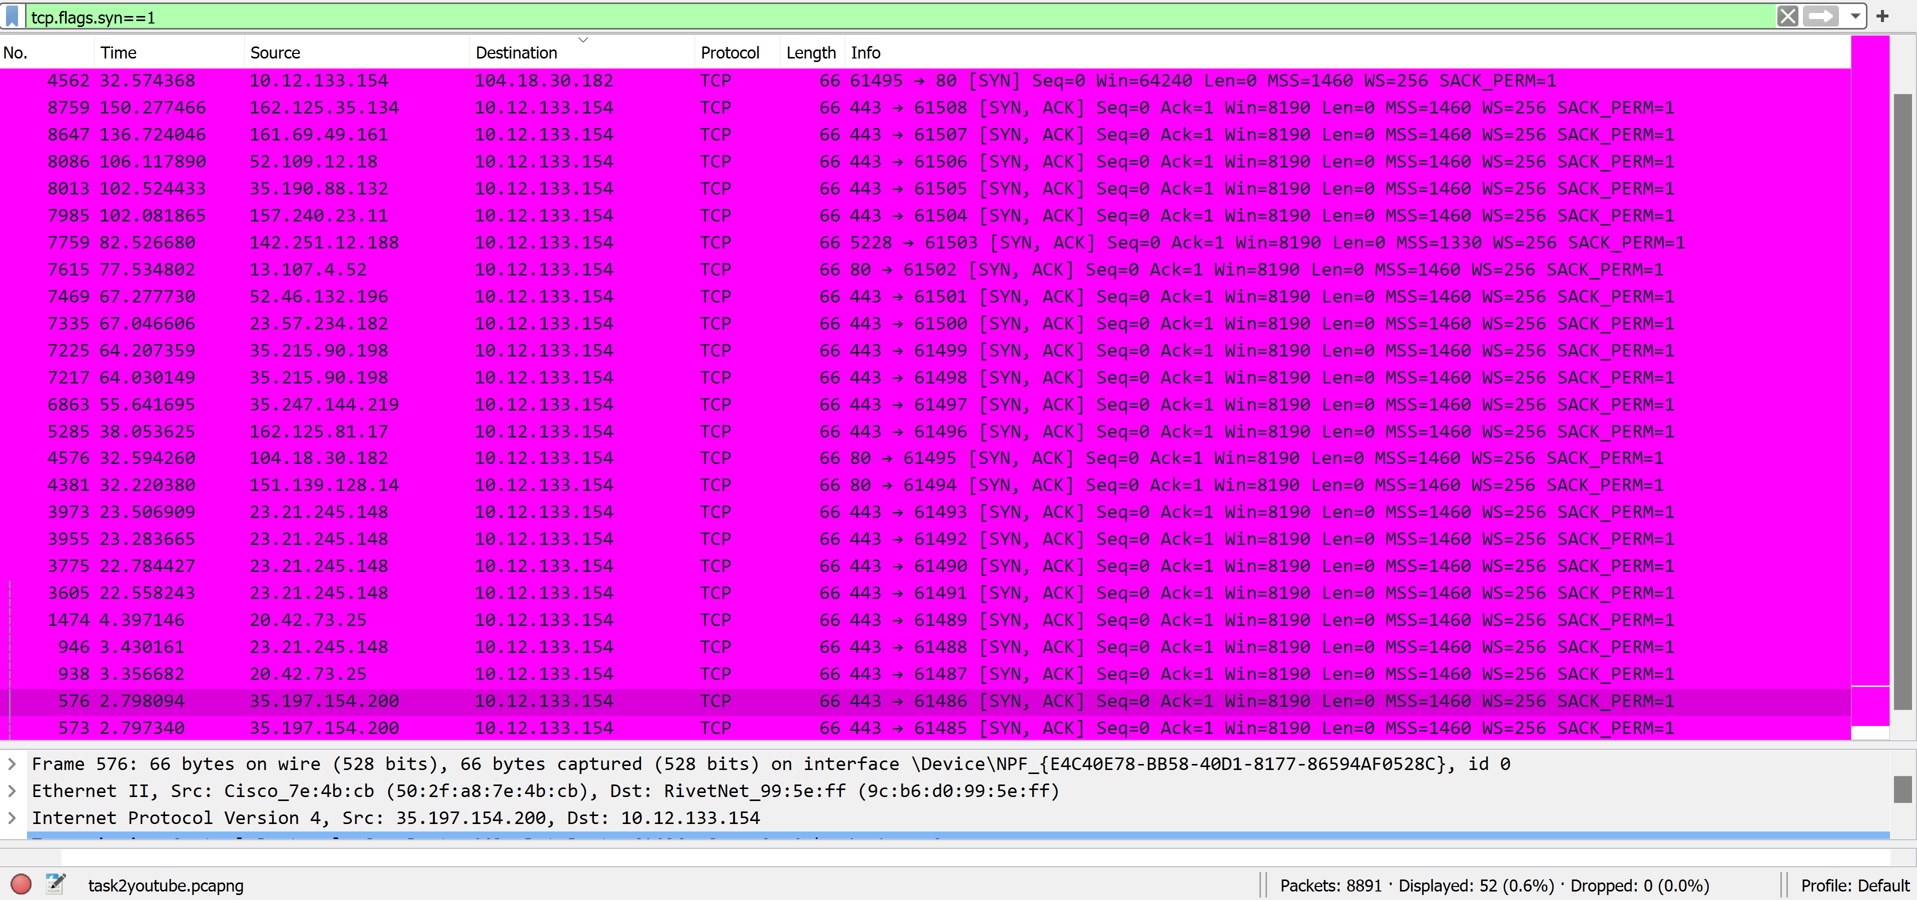

**A total of 52 Packets had had SYN flag set. So, it can be said that several connections were reestablished over the course of the capture.**

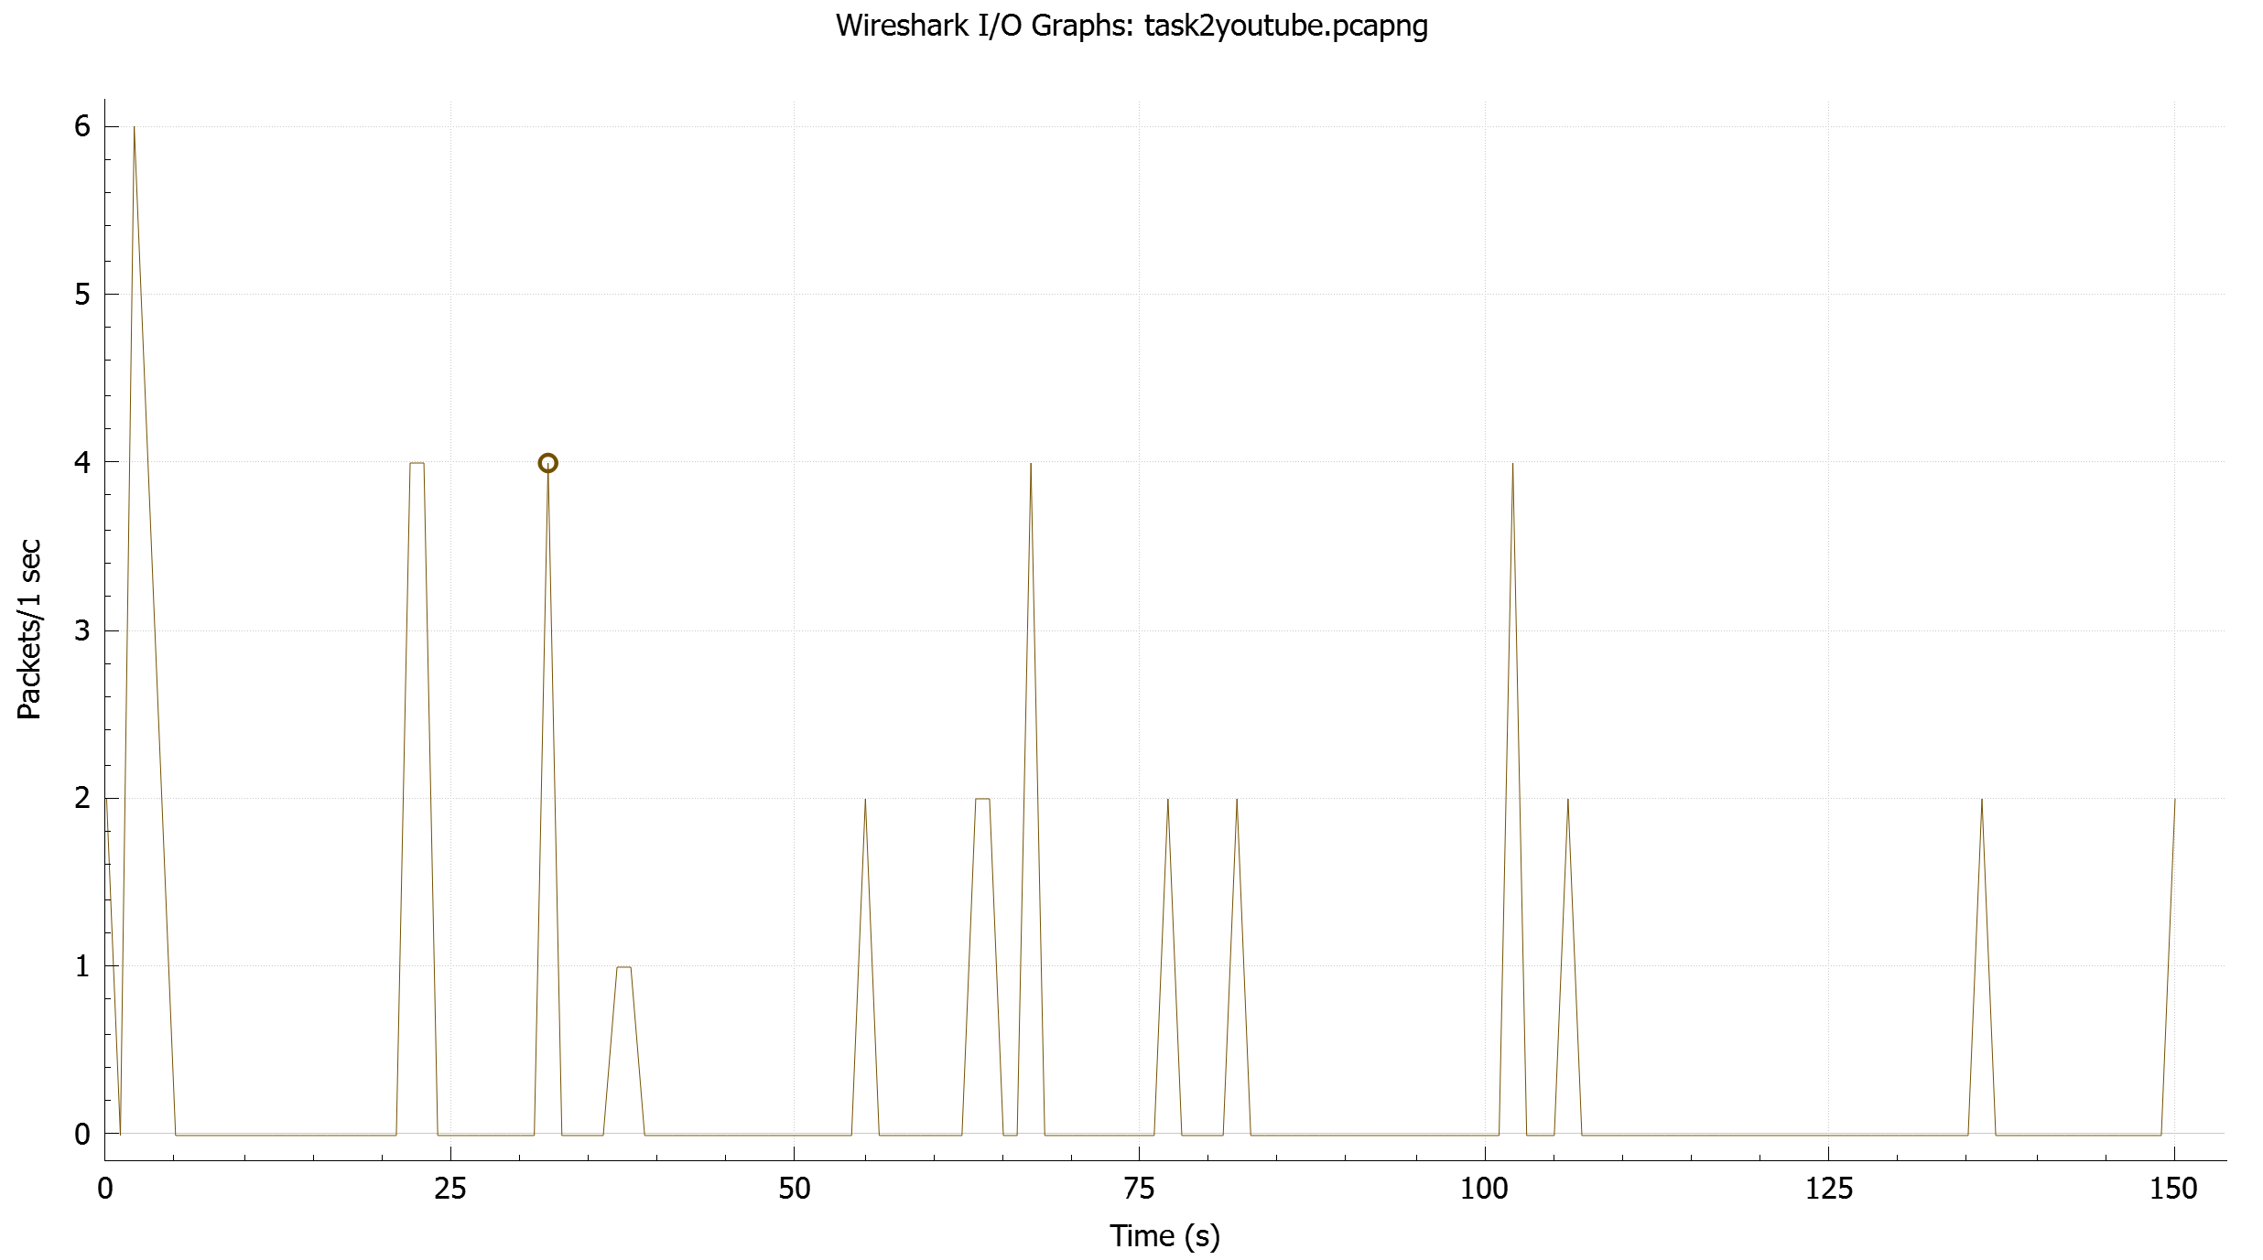

**Step-5: The number of packets that had PSH set was determined using the following filter:**

tcp.flags.push==1

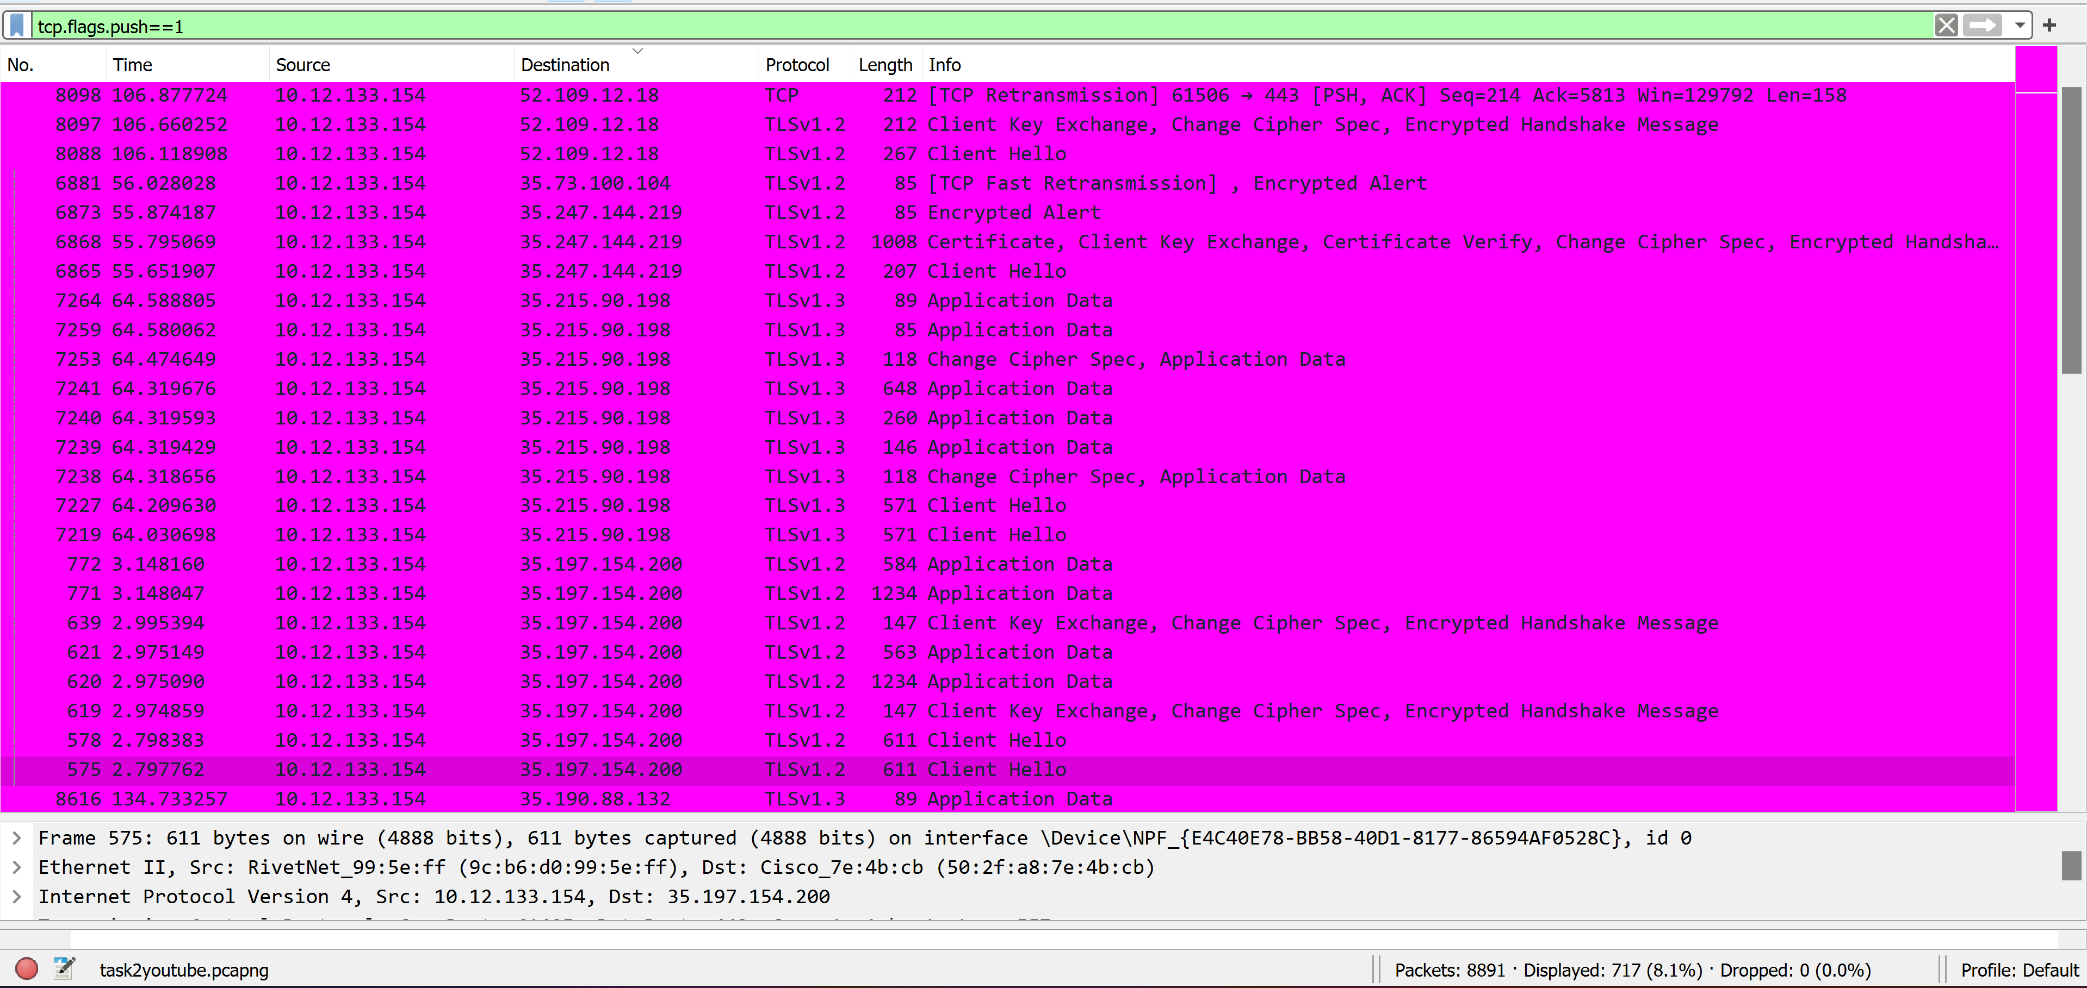

**A total of 717 Packets had PSH flag set. That is, a total of 717 data segments were transmitted over the entire duration.**

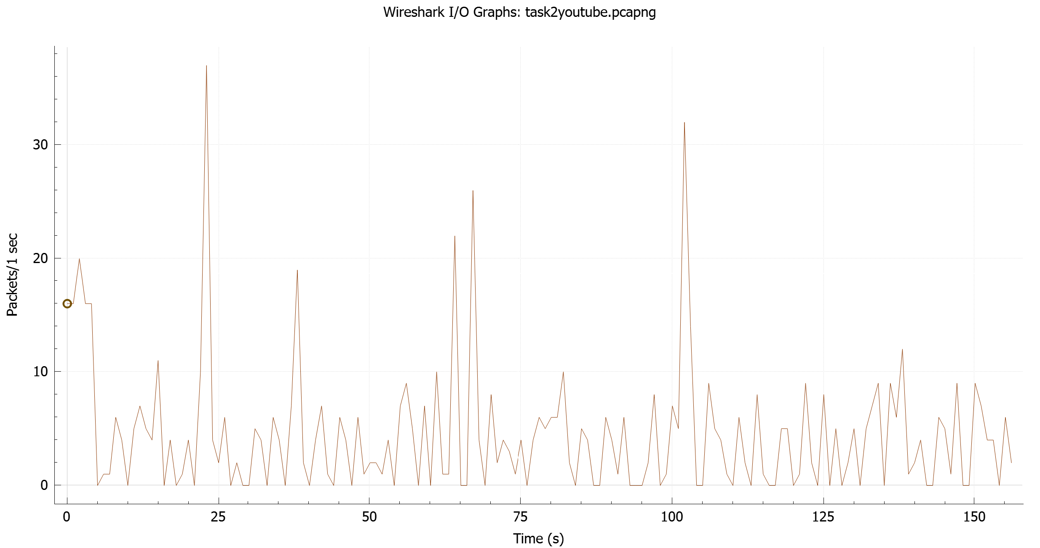

**Step-5: The number of packets that had RST set was determined using the following filter:**

tcp.flags.reset==1

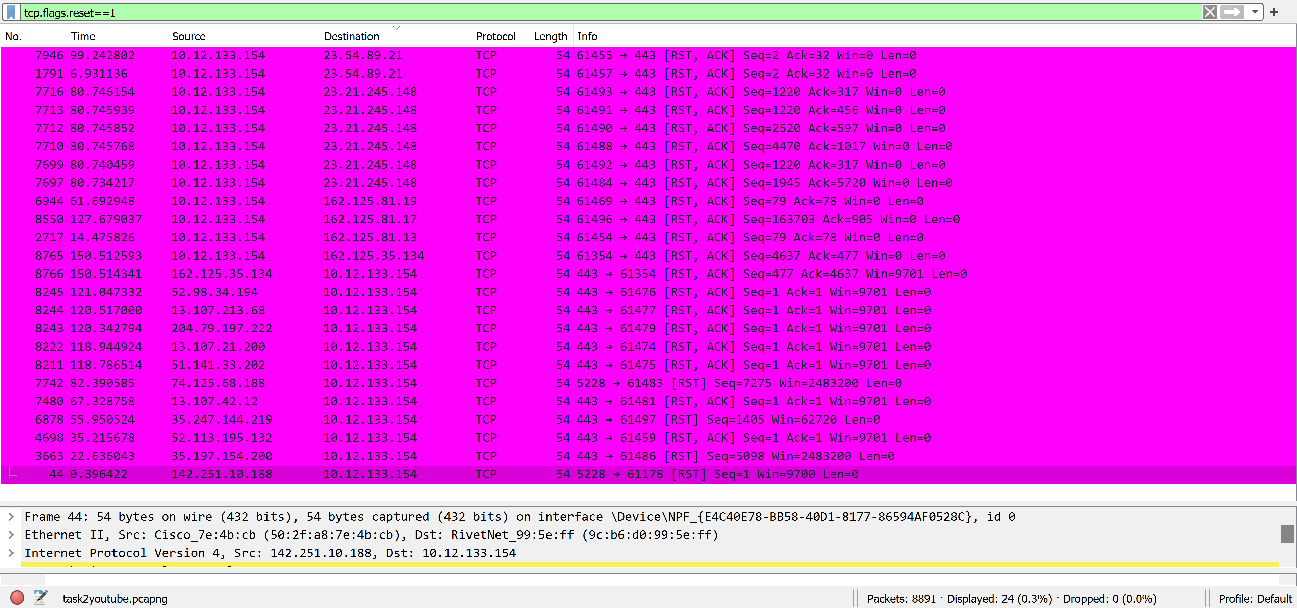

**A total of 24 Packets had RST flag set. This implies that the connection was reset 24 times over the course of the capture.**

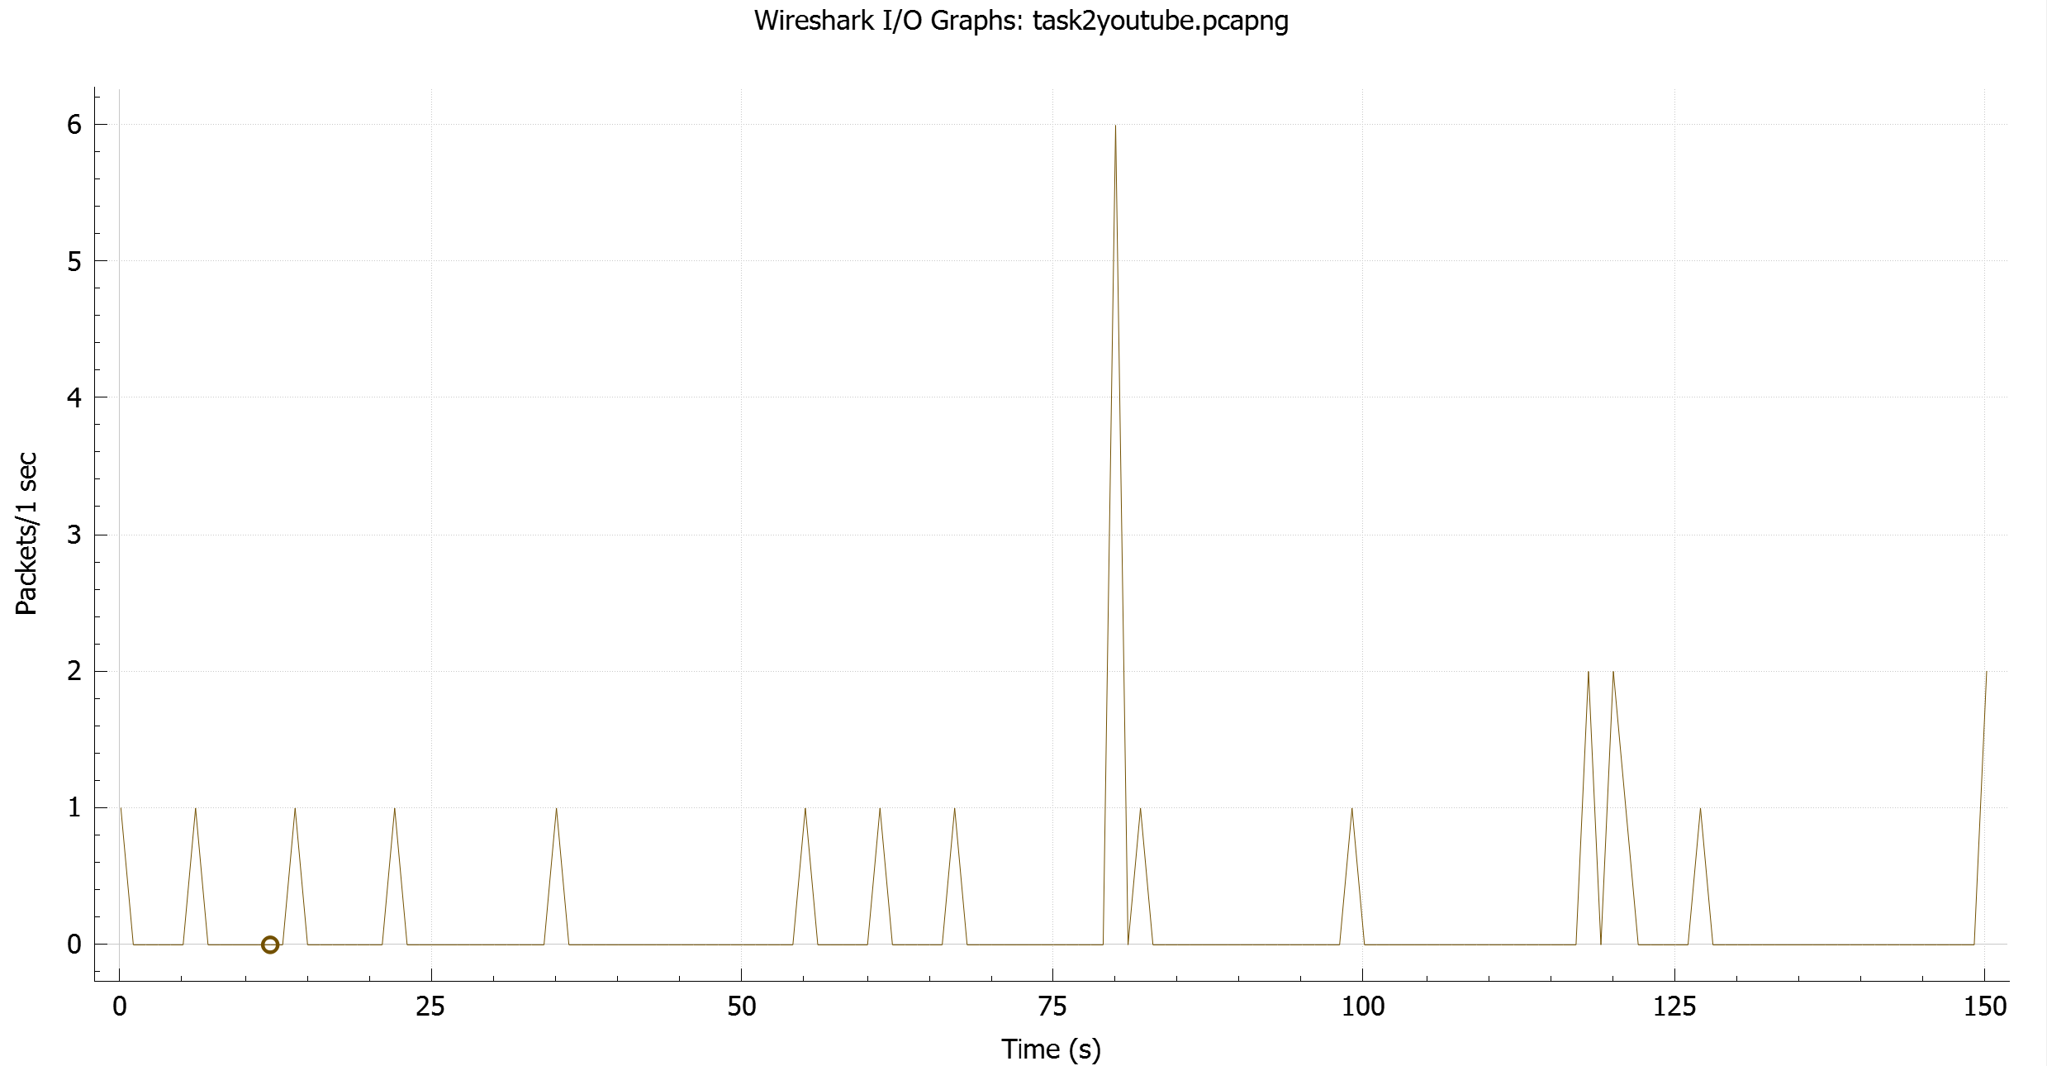

**References:**

[**http://www.ece.rutgers.edu/~marsic/books/CN/projects/wireshark/ws-project-1.html**](http://www.ece.rutgers.edu/~marsic/books/CN/projects/wireshark/ws-project-1.html)

[**https://ask.wireshark.org**](https://ask.wireshark.org)

[**https://www.wireshark.org**](https://www.wireshark.org)

[**http://wiki.wireshark.org/CaptureFilters#Default_Capture_Filters**](http://wiki.wireshark.org/CaptureFilters#Default_Capture_Filters)

[**http://www.howtogeek.com/104278/how-to-use-wireshark-to-capture-filter-and-inspect-packets/**](http://www.howtogeek.com/104278/how-to-use-wireshark-to-capture-filter-and-inspect-packets/)

[**http://www.webyield.net/ip/index.php**](http://www.webyield.net/ip/index.php)

[**https://www.youtube.com/watch?v=RyxPp22x9PU**](https://www.youtube.com/watch?v=RyxPp22x9PU)

[**http://www.youtube.com/watch?v=Yj0l7iGKh8g**](http://www.youtube.com/watch?v=Yj0l7iGKh8g)

[**http://packetlife.net/library/cheat-sheets/**](http://packetlife.net/library/cheat-sheets/)